# **Progress Updates**

## Goals:

* To determine the optimal clearance between the catheter and the structural elements using a simulation program
* To identify the optimal clearance that allows for the fastest delivery of the structural elements to the chamber device
* To determine the optimal dimension of the inner diameter of the catheter and the optimal dimension of the structural elements
* To determine the materials for structural elements and tube that provide the best results, which can be characterized as the fastest velocity with the same clearance

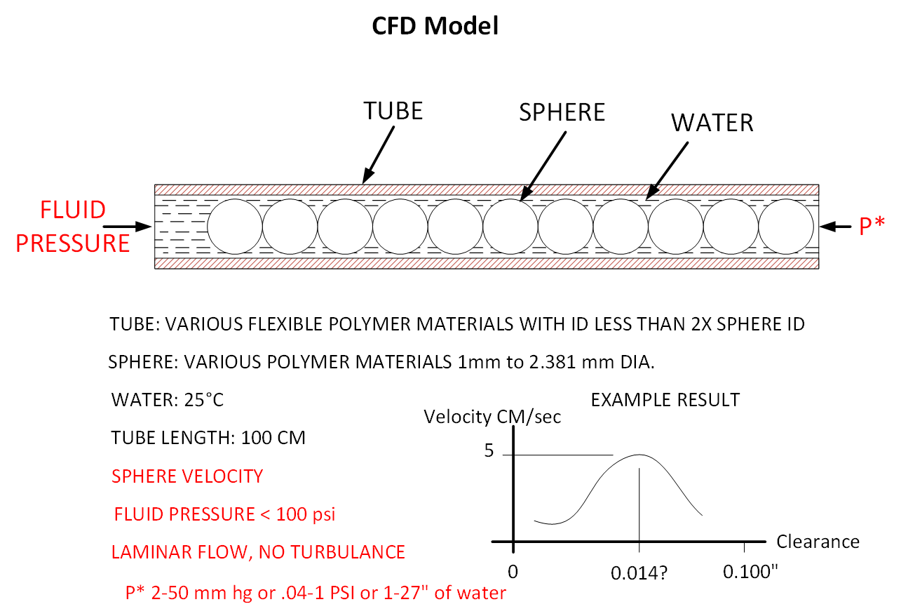

## Notes from previous discussions:

* Ashka reached out to professors about potential CFD software we could use. COMSOL and Fluent (part of ANSYS) were common recommendations
  + Software for creating the rigid model may be different than the software we use for the actual simulation part
* Journal article by Bungay and Brenner (1973) empirically derived equations for modeling the motion of closely fitting spheres in fluid filled tube and the pressure differential introduced and provided us with some relevant assumptions
  + Gerald suggested potentially solving some of these equations using our parameters in MATLAB to get some preliminary results that could potentially help validate our model for simulation down the line
    - Has anyone used MATLAB for this purpose?
    - We need to look into MATLAB’s CFD capabilities
    - Need to understand which equations from this paper apply to our model and if we have the appropriate parameters to fully define these equations
* Drawings from Gerald that better define the parameters of the delivery system
* Proposed 2.381 mm (3/32”) Sphere Prototype

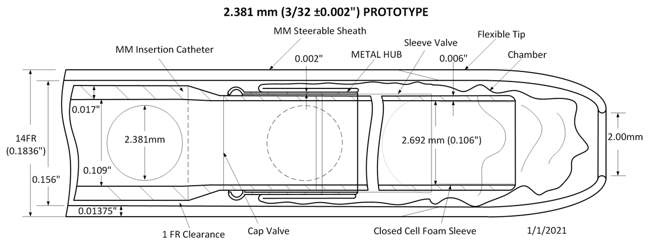

* Proposed 2.00 mm Sphere Prototype

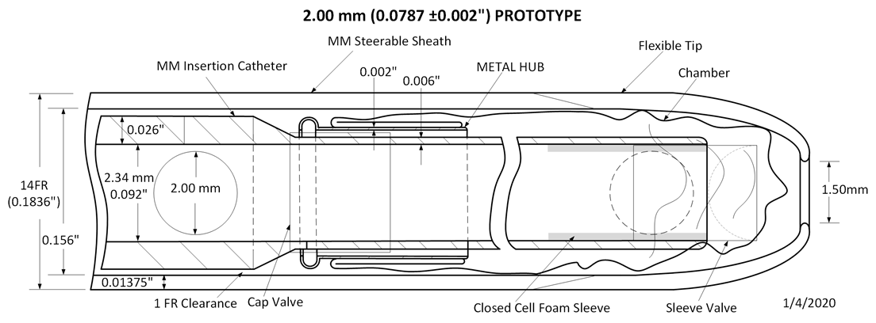

* Proposed 1.589 mm (1/16”)Sphere Prototype

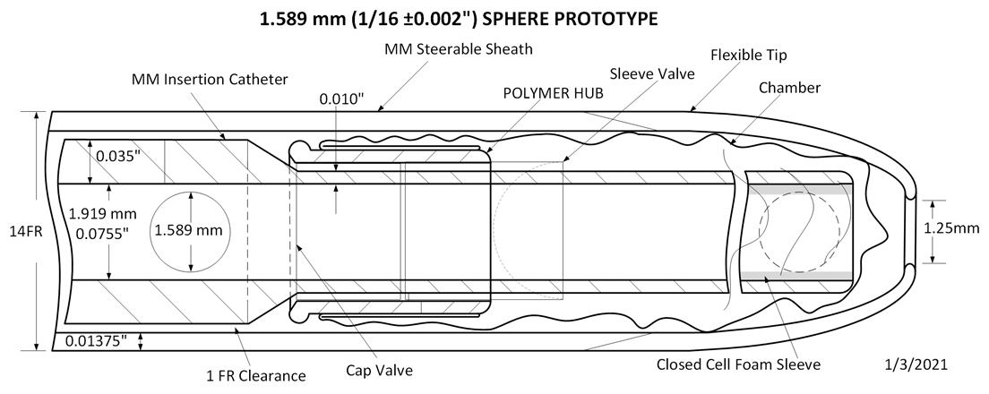

* Arnab has been working on a spreadsheet that also has more parameters that will help us establish boundary conditions and has some expected data regarding time to expand chamber, velocities, and force values
* Expected setup/parameter considerations:
  + Only model tube with structural elements first, than add more components once we establish proper procedures in desired software
  + Back pressure will be a summation of all pressures expected to be present (native pressure in LA/LAA, resistance from cap valve and sleeve, patient blood pressure, pressure needed to begin chamber expansion, resistance from foam sleeve at catheter tip, etc.)
  + Some dimensions are still undefined, but will hopefully become better defined once a complete assembly of the delivery system is created
  + Common reference geometry needs to be established:
    - Units
    - Coordinate system
    - Axes
    - Planes
    - Mating preferences
    - Reference points
    - For dimensions that are undefined, everyone should us the same “arbitrary” accommodations
    - Everyone needs to have a good understanding of how the components are assembled, their function, and order of deployment***
* I’m working with the FEA team to create and assemble the delivery system components, as they are working on understanding the stress and strain resulting from various material properties associated with each component

## Next steps:

* Decide on a simulation software
  + COMSOL doesn’t have free license, but ANSYS does through GT
* Preliminary results using equations from paper in MATLAB
  + CFD solving capabilities of MATLAB
  + Isolate which equations from paper are relevant for our purposes
  + Ensure we have established parameters to fully define those equations
* Establish general protocol for CFD simulations
  + Link to info about CFD basics in ANSYS Fluent: <https://www.slideshare.net/muhammadshujan/cfd-ansys-fluent>
  + Link to info about CFD procedures from NASA: <https://www.grc.nasa.gov/www/wind/valid/tutorial/process.html>
  + FEA procedures document has a lot of helpful information that is relevant to this project as well that we can reference
  + Find some videos that walks through these steps
* Establish specific protocol for CFD simulations in our software of choice
  + Find a complete tutorial of some CFD simulation on an arbitrary component that walks through all steps, before applying this to our own model
  + Define necessary parameters/assumptions for initial simulation:
    - Tube/insertion catheter length and diameter (several lengths and internal diameters could be tested)
    - Structural element size (sizes between 1mm - 2.381mm will be tested)
    - Back pressure value that includes all expected pressures (native pressure in LA/LAA, resistance from cap valve and sleeve, patient blood pressure, pressure needed to begin chamber expansion, resistance from foam sleeve at catheter tip, etc.)
    - Structural elements will remain axisymmetric with the catheter
    - The pressure differential will be great enough to prevent any lateral movement, so only translational motion will be present
    - Structural elements can be modeled as an infinite train of touching spheres
    - Inertial effects can be ignored
    - Structural elements and fluid should have the same mean velocity
    - No angular velocity
    - Laminar flow, no turbulence

# **Theoretical Solutions**

## MATLAB CFD capabilities

Software justification

* Software of choice: Matlab (https://www.mathworks.com/matlabcentral/fileexchange/72640-cfdtool-matlab-cfd-simulation-gui-toolbox)

**Features:**

* Fully free CFD toolbox that is downloadable on virtually any device (windows, mac, Linux)
* completely stand-alone and self-contained toolbox
* fully integrated and easy to use Graphical User Interface (GUI)
* modeling and simulation in 1D, 2D, 3D, and axisymmetric/cylindrical coordinate systems
* seamless OpenFOAM® and SU2 CFD solver integrations
* built-in geometry and CAD tools
* automatic mesh and grid generation
* pre-defined equations and boundary conditions:
* incompressible viscous fluid flows (Navier-Stokes equations)
* compressible inviscid flows (Euler equations)
* heat transfer (Convection and Conduction)
* multiphysics support for fluid flow and thermal analysis
* simulation of laminar and turbulent flows (k-epsilon and k-omega turbulence models available together with OpenFOAM)
* stationary and time-dependent analysis types
* postprocessing and visualization
* **Optional OPENFOAM CFD Solver?**

* What conditions can/need to be defined? **(https://www.youtube.com/watch?v=ZnnXl7ryBMI)**
* for MATLAB CFD, the Reynolds Number is set to be equal to 20
* Must select Navier-Stokes equations from the ‘select physics’ menu
* select 2D as dimensions we are working with
* set min and max coordinates for x to be (0, 2.2) and y to be (0,0.41) to create a proper rectangle for the sphere to go through (can be adjusted based on our numbers for our delivery system)
* the sphere’s x and y radius should be 0.05 centered at ( 0.2,0.2)- (can be adjusted based on our delivery system)
* Need to set grid system to be 0.02
* How do these equations need to be organized/formatted?

**Equations:**

* When clicking on the ‘select physics’ option, by clicking on Navier-Stokes equations, the program will automatically be set up with the appropriate equations
* In “Equations Settings” dialogue box, can adjust density and viscosity appropriately)

**Boundary Settings:**

* Boundary settings include laminar inflow profile, constant pressure outflow, and no slip wall conditions (default mode)
* What will the results look like?
* Click solve mode after filling in numbers based on our delivery system to get results: will be a thermal view of a sphere moving through the rectangular tube
* can activate the contour and arrow plot options to see how the sphere is moving- showcases a steady laminar flow in the direction where the sphere should be moving and a recirculation zone behind the sphere
* can get pressure difference as well from Post/Line evaluation in ‘Post’ menu (can set to be .15, .25 for x and .2, .2 for y values or based on our values in the delivery system as well)
* Set boundary segments to be (5,-8)
* Can also enter drag force
* How will the results be interpreted?
* Results show a fully detailed diagram of a sphere flowing in a cylinder as a thermal image
* Contains arrows representing the flow of the fluid surrounding the sphere and within the tube

## Relevant Equations from Bungay and Brenner (1973) (look at section 2 and 3 of model constraints; section 7)

* Which case most closely resembles our testing conditions?
* A case that most closely represents our testing conditions is a long cylinder filled with Newtonian fluid with a viscosity and density that flows in a constant laminar flow; the sphere has a radius, a, suspended in the fluid (*Bungay and Brenner*, 27).
* We seek to find the pressure drop from the presence of the sphere
* Which equations are associated with modeling this scenario?
* The kinematic equations derived from Navier-Stokes equations (figure 2.3 and 2.4) (*Bungay and Brenner*, 28).
* Figure 2.5 contains the volumetric flow rate of the cylinder
* Angular velocity vector can be defined in figure 3.3 (*Bungay and Brenner*, 31).
* Pressure drop expression equation is represented by figure 7.3 (*Bungay and Brenner*, 46).
* What parameters are defined by these equations?
* A circular cylindrical coordinate system must be defined (*Bungay and Brenner*, 29)
* Figures 2.10-2.12 define boundary conditions
* What are the assumptions/constraints described?
* Figure 2.13 contains a constraint of the velocity field that we define
* Boundary conditions defined by figures 2.10-2.12
* What aspects are different from our testing conditions?
* Navier-Stokes equations are already defined
* What results will these equations yield when solved?
* Results similar to the CFD simulation on Matlab

## Parameters Needed to Define Equations

* Need to set up proper boundary and grid specifications (located in mode toolbar)
* Certain equations are needed to create simulation: This includes Navier Stokes Equations, pressure drop equation (optional), etc.
* Rest of equations defined from Bungay and Brenner (section above)

## Solving Equations in MATLAB

Note: Modeling equations:

- *Geometry* - Definition of the geometry to be modeled

- *Grid* - Subdivision of the geometry into smaller cells suitable

for computation

- *Equation* - Specification of material parameters and coefficients

- *Boundary* - Boundary conditions specify how the model interacts

with the surrounding environment (outside the geometry)

- *Solve* - Solution and simulation of the defined model problem

- **Post** - Visualization and postprocessing

**Next steps:**

Holding off MATLAB for now; working with ANSYS simulations before going back to MATLAB.

# 

# 

# 

# 

# 

# 

# 

# 

# 

# 

# 

# 

# **CFD Background**

## Background for General Procedures

### What is CFD?

Computational fluid dynamics (CFD; Computational Fluid Mechanics (CFM) is also a commonly used term but refers to the same type of analysis) is a branch of fluid mechanics that uses numerical analysis and data structures to analyze and solve problems that involve fluid flows. Computers are used to perform the calculations required to simulate the free-stream flow of the fluid, and the interaction of the fluid (liquids and gases) with surfaces defined by boundary conditions.

CFD investigations are used to clarify the characteristics of various bioengineering flows in details that are beyond the capabilities of experimental measurements. To analyze these conditions, CAD models of the human vascular system are extracted employing modern imaging techniques such as MRI or Computed Tomography. A 3D model is reconstructed from this data and the fluid flow can be computed. Blood properties such as density and viscosity, and realistic boundary conditions (e.g. systemic pressure) have to be taken into consideration. Therefore, making it possible to analyze and optimize the flow in the cardiovascular system for different applications.

Examples: 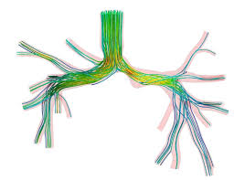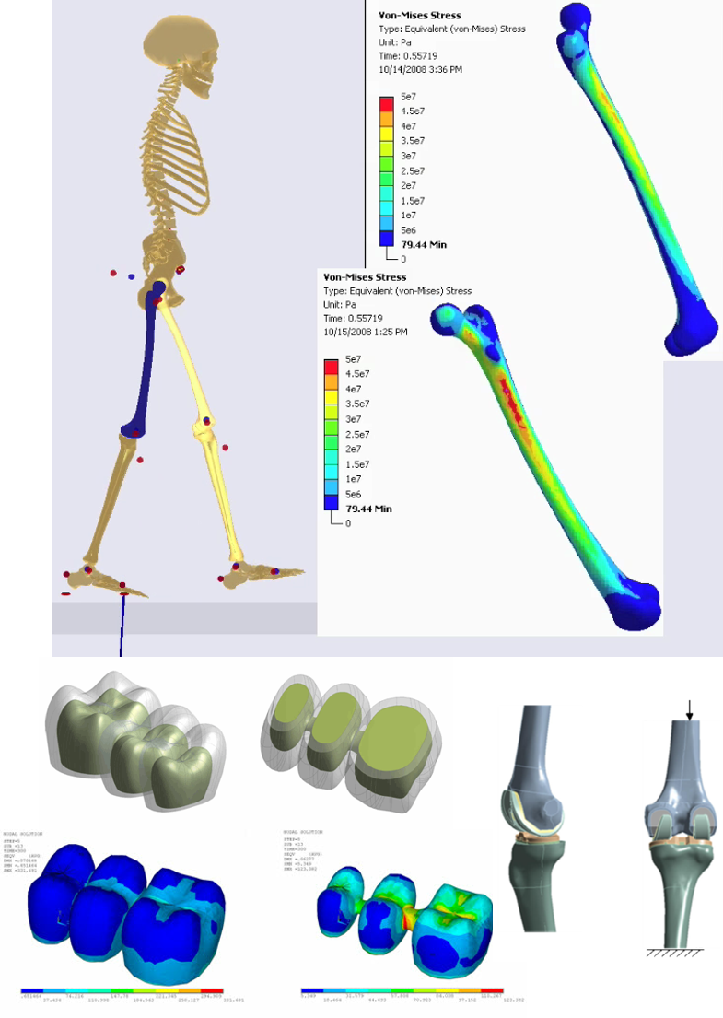

### What is a mesh?

A Mesh is a network that is formed of cells and points. Meshing is an integral part of the engineering simulation process where *complex geometries are divided into simple elements that can be used as discrete local approximations of the larger domain*. The Mesh can be resembled into any shape and size depending upon the geometry and is used to resolve partial differential equations.

Based on the types of grids, the mesh can be classified into *structured and unstructured mesh* depending on the layout of the mesh.

*Unstructured Mesh*: meshes with general connectivity whose structure is arbitrary (random) and hence the connectivity between the elements must be defined and stored. The unstructured element types have triangular elements (2D) or tetrahedral (3D) elements

*Structured Mesh*: are meshes with implicit (absolute) connectivity whose structure allows for easy identification of elements and nodes. In general, the structured meshes have quadrilateral elements (2D) or hexahedral (3D) elements.

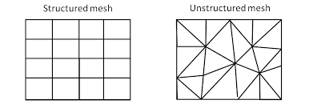

Figure 2: The Image showing comparison between structured and unstructured mesh

<https://skill-lync.freshdesk.com/support/solutions/articles/43000583840-introduction-to-meshing-and-inserting-a-method-in-ansys>

*Terminology:*

• Cell = control volume into which domain is broken up.

• Node = grid point.

• Cell centre = centre of a cell.

• Edge = boundary of a face.

• Face = boundary of a cell.

• Zone = grouping of nodes, faces, cells

• Domain = group of node, face and cell zones. 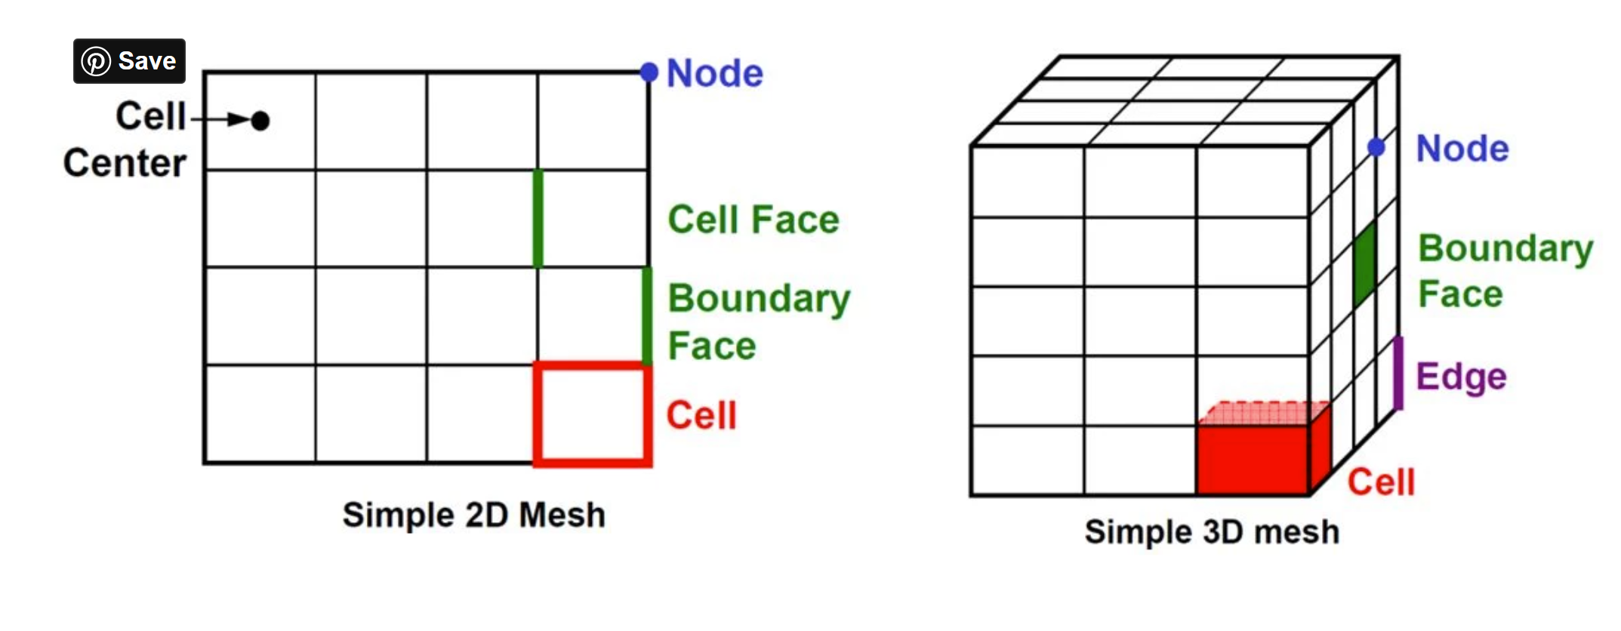

<https://www.manchestercfd.co.uk/post/all-there-is-to-know-about-different-mesh-types-in-cfd#:~:text=A%20mesh%20divides%20a%20geometry,Terminology%3A&text=The%20shapes%20of%20control%20volumes,and%20hexahedrons%20in%203D%20flows>.

*3D mesh cell types:*

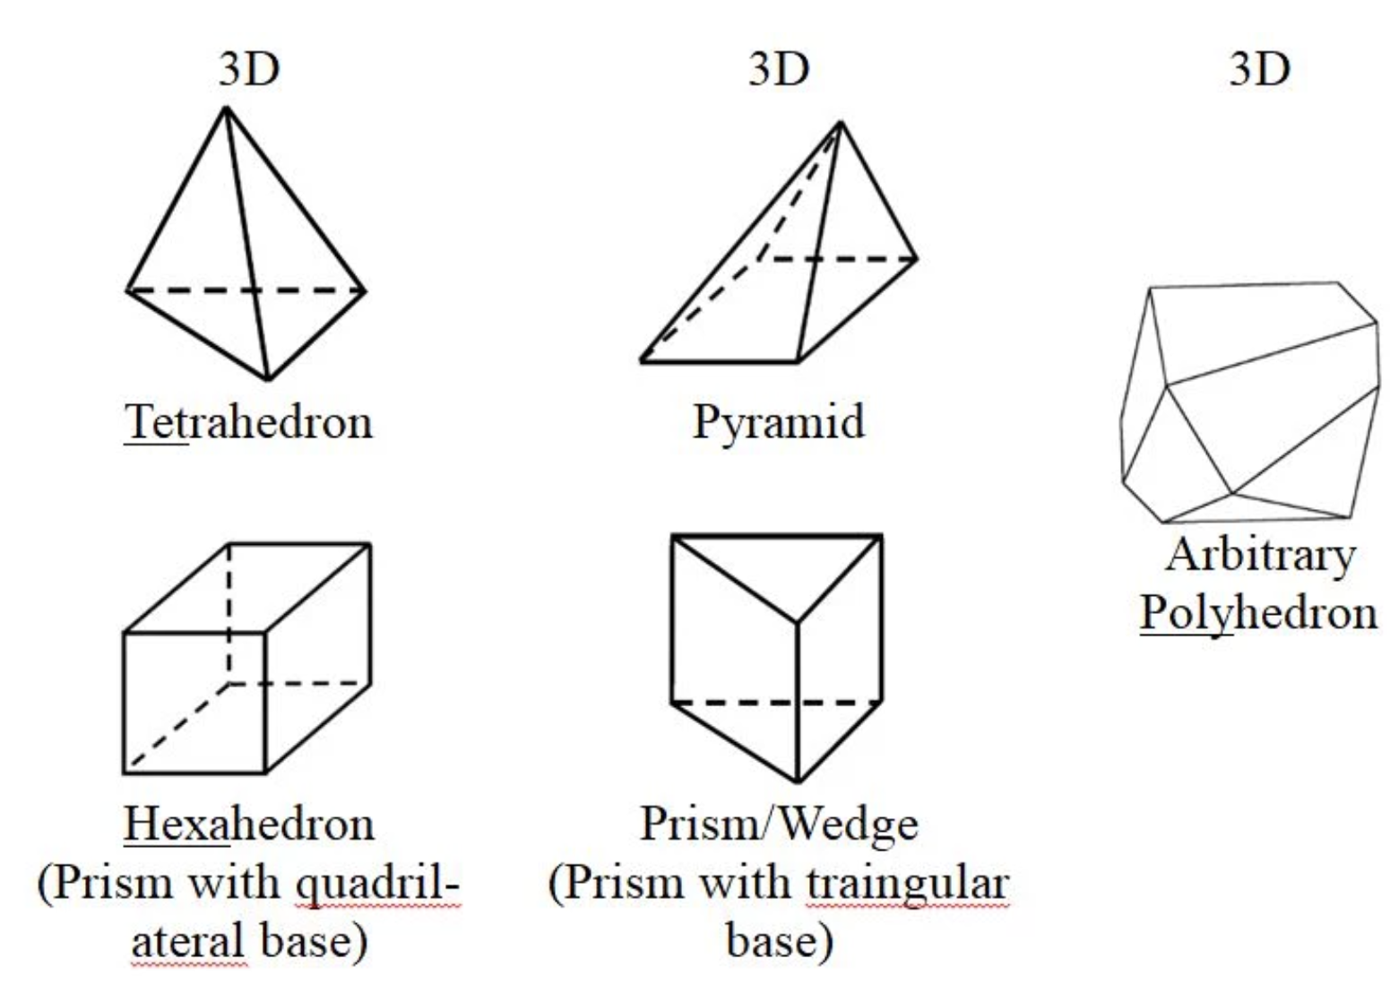

When *choosing mesh type*, consider the following issues:

* *Setup time*: The creation of structured or block-structured meshes (consisting of quadrilateral or hexahedral elements) for such problems can be extremely time-consuming if not impossible. Therefore, setup time for complex geometries is the major motivation for using unstructured meshes employing triangular or tetrahedral cells. However, if your geometry is relatively simple, there may be no saving in setup time with either approach.
* *Computational expense*: When geometries are complex or the range of length scales of the flow is large, a triangular/tetrahedral mesh can be created with far fewer cells than the equivalent mesh consisting of quadrilateral/hexahedral elements, which will cut down the time for creating the mesh
  + For simple geometries, use quadrilateral/hexahedral meshes.
  + For moderately complex geometries, use unstructured quadrilateral/hexahedral meshes.
  + For relatively complex geometries, use triangular/tetrahedral meshes with prism layers.
  + For extremely complex geometries, use pure triangular/tetrahedral meshes.
* *Numerical diffusion*:
  + A dominant source of error in multidimensional situations is numerical diffusion (false diffusion). The term *false diffusion* is used because the diffusion is not a real phenomenon, yet its effect on a flow calculation is analogous to that of increasing the real diffusion coefficient.
  + *The amount of numerical diffusion is inversely related to the resolution of the mesh.* Therefore, one way of dealing with numerical diffusion is to *refine the mesh.*
  + *Numerical diffusion is minimized when the flow is aligned with the mesh*.  
    This is the most relevant to the choice of the mesh. If you use a triangular/tetrahedral mesh, the flow can *never* be aligned with the mesh. If you use a quadrilateral/hexahedral mesh, this situation might occur, but *not for complex flows*. It is only in a *simple* flow, such as the flow through a long duct, in which you can rely on a quadrilateral/hexahedral mesh to minimize numerical diffusion. In such situations, it is advantageous to use a quadrilateral/hexahedral mesh, since you will be able to get a better solution with fewer cells than if you were using a triangular/tetrahedral mesh.

*Determining mesh quality:*

The quality of the mesh plays a significant role in the *accuracy and stability* of the numerical computation.

Depending on the type of mesh, ANSYS will provide data on the quality of the mesh:

* *Max cell skewness*: Highly skewed cells can decrease accuracy and destabilize the solution.A general rule is that the maximum skewness for a triangular/tetrahedral mesh in most flows should be kept below 0.95, with an average value that is less than 0.33.
* *Max cell squish index*: The worst cells will have a cell squish index close to 1, with better cells closer to 0.
* *Max aspect ratio*: a measure of the stretching of the cell. Generally, it is best to avoid aspect ratios in excess of 5:1 in the bulk flow (away from the walls).

*Mesh Examples:*

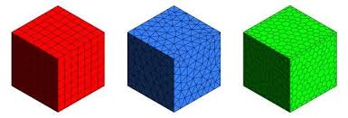

Red: hexahedral Blue: tetrahedral Green: polyhedral

### What are boundary conditions?

Boundary conditions define the inputs of the simulation model. Some conditions, like velocity and volumetric flow rate, define how a fluid enters or leaves the model. Other conditions, like film coefficient and heat flux, define the interchange of energy between the model and its surroundings. Some boundary conditions will define spatial constraints to allow only certain portions of the model to move.

Boundary conditions connect the simulation model with its surroundings. Without them, the simulation is not defined, and in most cases cannot proceed. Most boundary conditions can be defined as either steady-state or transient. Steady-state boundary conditions persist throughout the simulation. Transient boundary conditions vary with time, and are often used to simulate an event or a cyclical phenomena.

Initial conditions are a different type of condition that are active only at the beginning of the simulation.

<https://knowledge.autodesk.com/support/cfd/learn-explore/caas/CloudHelp/cloudhelp/2019/ENU/SimCFD-UsersGuide/files/GUID-F1CF2005-3FD3-4A0C-9224-0093F875D697-htm.html>

First you must identify the location of the boundaries (e.g., inlets, walls, symmetry), then you can proceed to supply information at the boundaries

<https://www.southampton.ac.uk/~nwb/lectures/GoodPracticeCFD/Articles/BCs_Fluent-v6.3.04.pdf>

*Common Types of Boundary Conditions:*

* Velocity inlet boundary conditions are used to define the velocity and scalar properties of the flow at inlet boundaries.
* Pressure inlet boundary conditions are used to define the total pressure and other scalar quantities at flow inlets.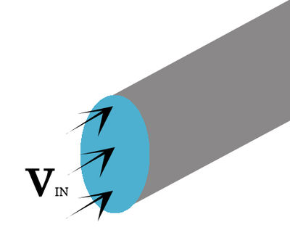
* Pressure outlet boundary conditions are used to define the static pressure at flow outlets (and also other scalar variables, in case of backflow). The use of a pressure outlet boundary condition instead of an outflow condition often results in a better rate of convergence when backflow occurs during iteration.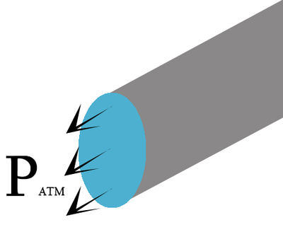
* Mass flow inlet boundary conditions are used in compressible flows to prescribe a mass flow rate at an inlet. It is not necessary to use mass flow inlets in incompressible flows because when density is constant, velocity inlet boundary conditions will fix the mass flow. Like pressure and velocity inlets, other inlet scalars are also prescribed.
* Outflow boundary conditions are used to model flow exits where the details of the flow velocity and pressure are not known prior to solution of the flow problem. They are appropriate where the exit flow is close to a fully developed condition, as the outflow boundary condition assumes a zero streamwise gradient for all flow variables except pressure. They are not appropriate for compressible flow calculations.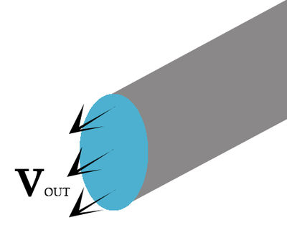
* Wall boundary conditions are used to bound fluid and solid regions. In viscous flows, the no-slip boundary condition is enforced at walls by default, but you can specify a tangential velocity component in terms of the translational or rotational motion of the wall boundary, or model a "slip'' wall by specifying shear.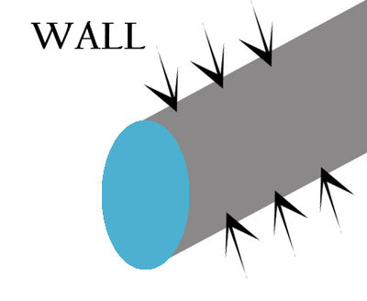
* Symmetry boundary conditions are used when the physical geometry of interest, and the expected pattern of the flow/thermal solution, have mirror symmetry. 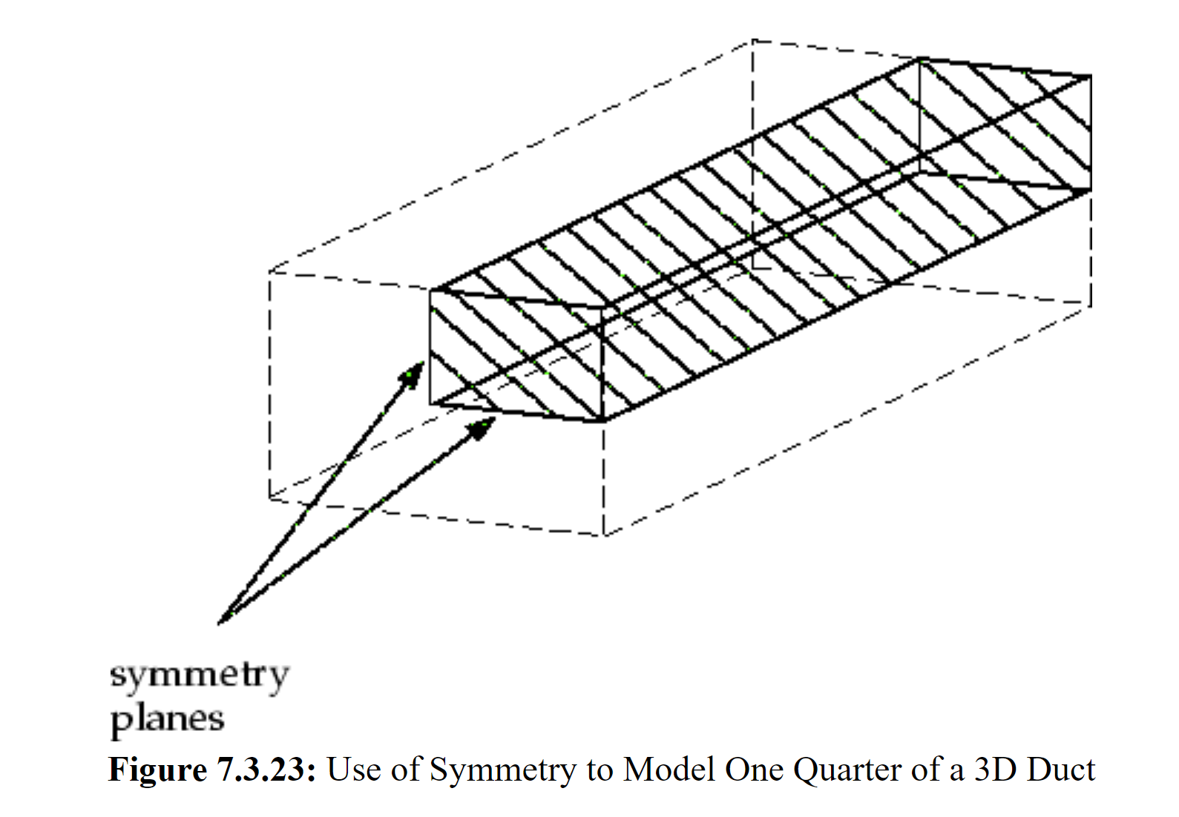
* Periodic boundary conditions are used when the physical geometry of interest and the expected pattern of the flow/thermal solution have a periodically repeating nature. 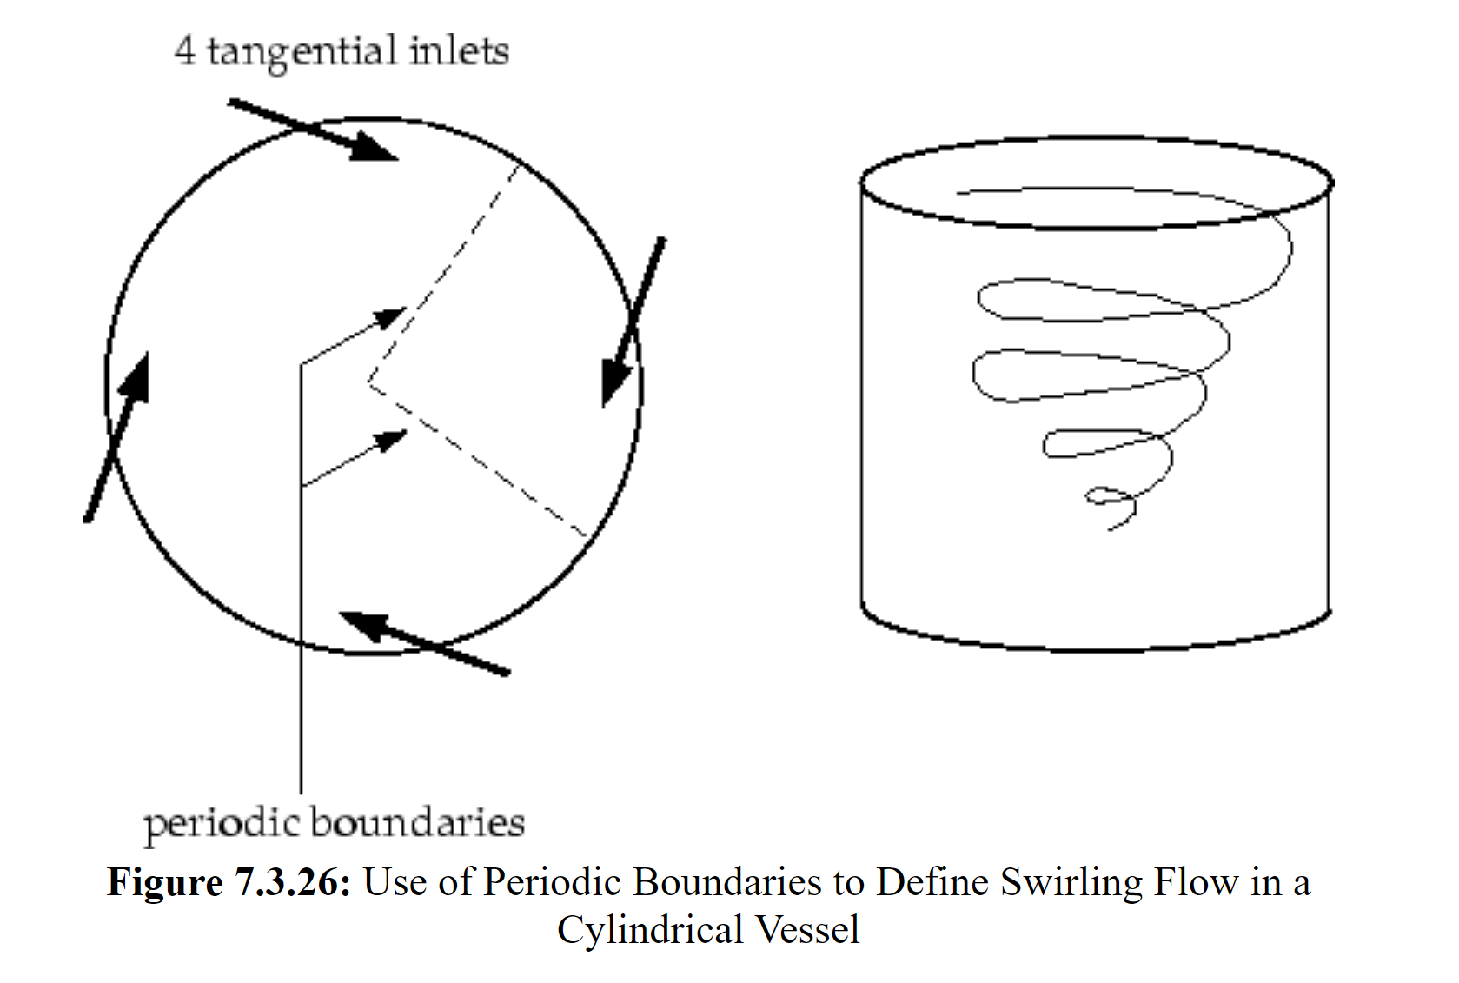
* Axis boundary conditions must be used as the centerline of an axisymmetric geometry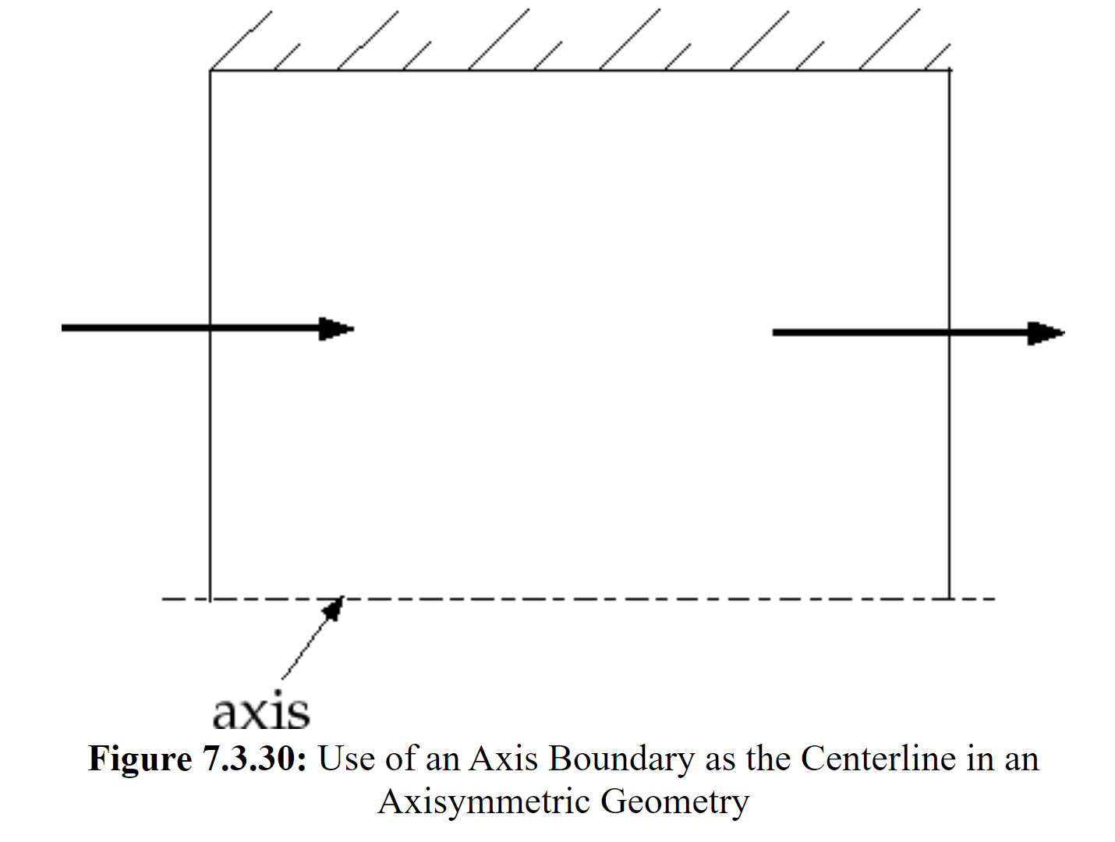

<https://www.afs.enea.it/project/neptunius/docs/fluent/html/ug/node236.htm>

Running simulations inside vs. outside of the model

### 

### What will results look like?

Once a simulation is completed, the results can be viewed and analyzed in post processing. The results of CFD simulations are often displayed using contours. A contour plot uses discretely colored areas to show how a certain variable varies over a region, with the color relating to the value of the specified variable. Contours of variables such as velocity, temperature, and pressure allow the results to be visualized and show how the values vary throughout the fluid flow.

*Contour Examples:*

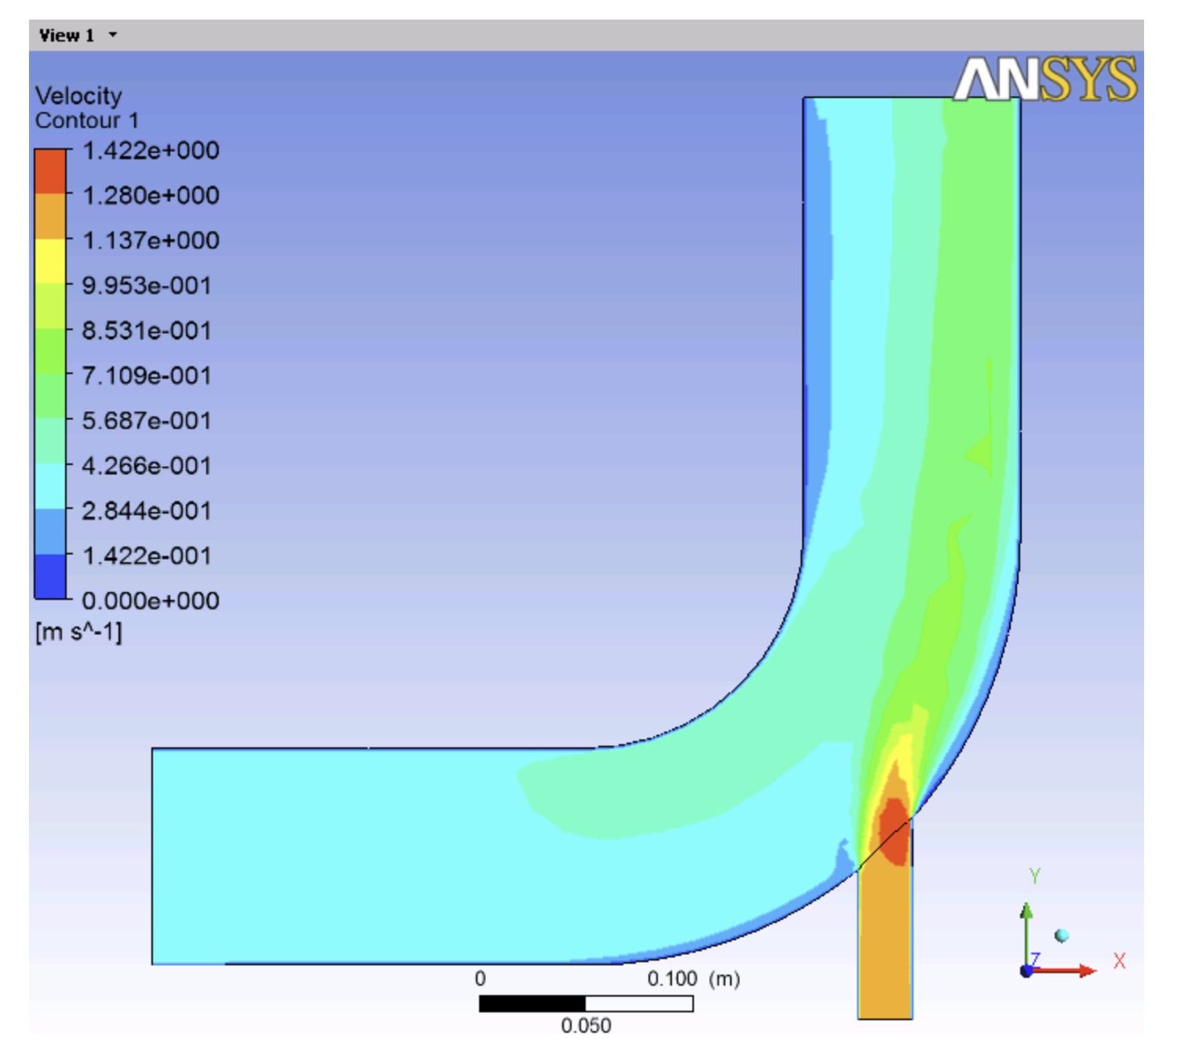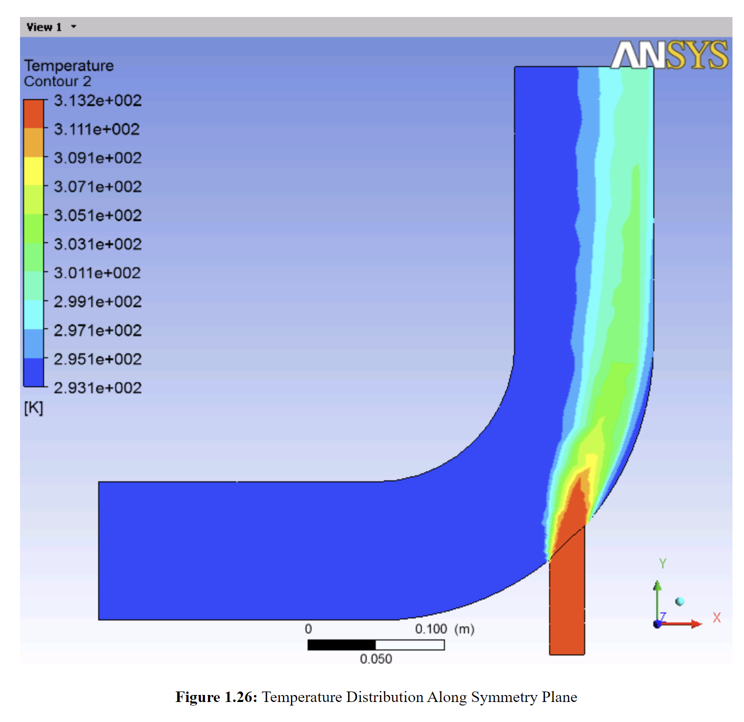

Two-dimensional contours display the values of a selected variable resulting from the simulation for a specific plane. This contour plane can be changed based on the region that needs to be analyzed. For instance, for a simulation of fluid flowing through a pipe, it might be useful to see both the circular cross-sectional view of velocity as well as a view of the plane cutting through the center. The circular cross-section would give a better picture of how the fluid’s velocity changes radially, and a view of the central plane would give a better picture of how the velocity changes along the length of the pipe.

*Changing Contour Plane Examples:*

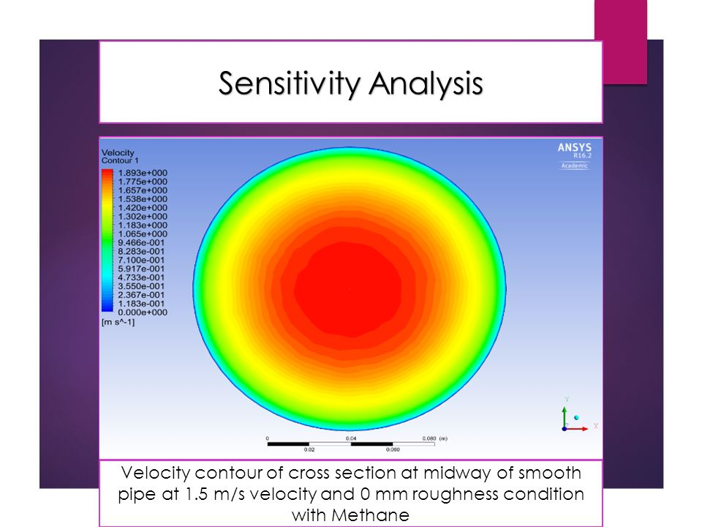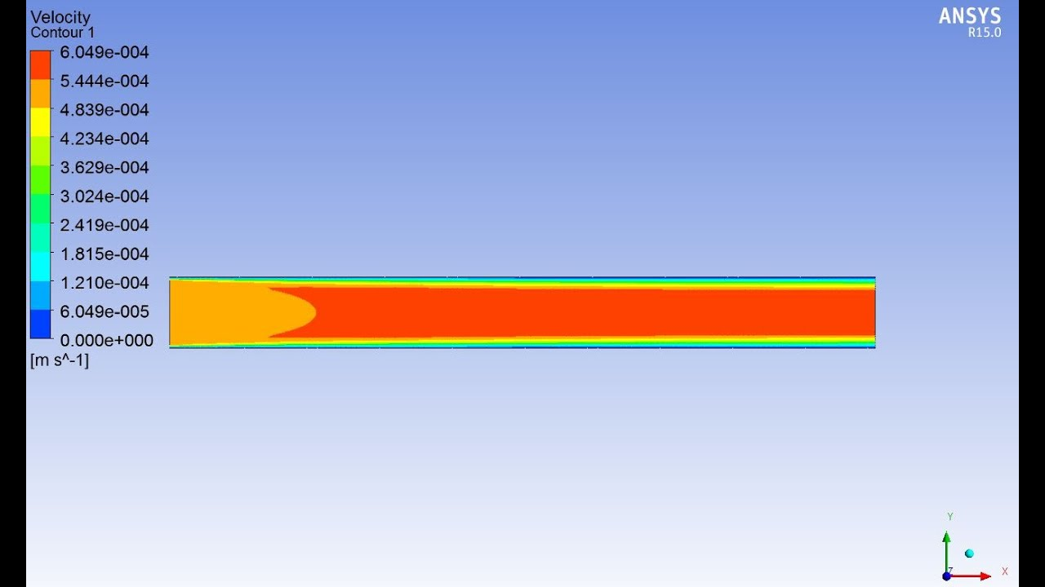

Other ways that results can be viewed include vector plots, streamlines.

*Vector Plots:*

A vector plot is a spatial representation of using vectors to show the magnitude and direction of a variable. Vector plots are most often used to display velocity.

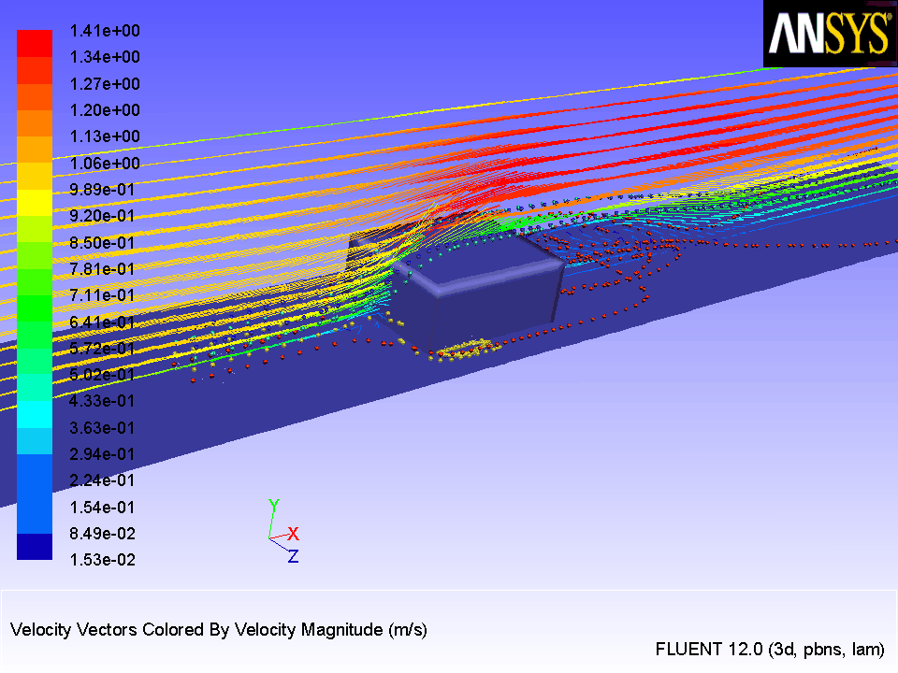

*Streamlines:*

A streamline is a line tangential to the instantaneous velocity vectors. Streamlines are used in fluid dynamics to visualize the motion of fluid or the path that a particle in the fluid would take.

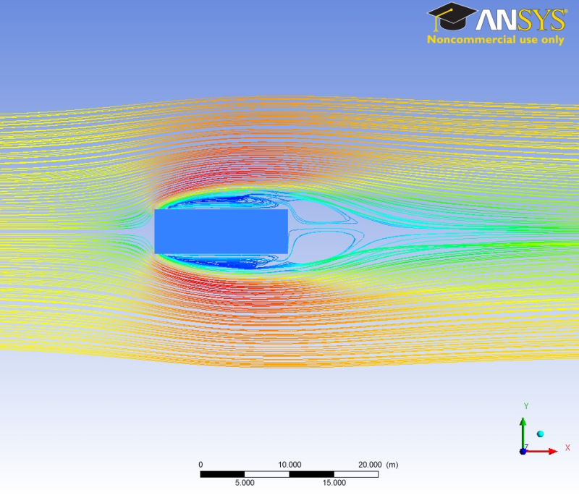

In ANSYS, post processing is done using CFD-post. In order to open CFD-post

* Start ANSYS Workbench.
* Locate the desired Fluid Flow in the Project Schematic
* Double-click Results.

<https://www.afs.enea.it/project/neptunius/docs/fluent/html/wbtg/node11.htm>

### How are results interpreted?

The results of CFD simulations are interpreted by understanding the data displayed in the diagrams such as contours, vector plots, and streamline plots. Looking at the results of the simulations can inform design decisions and show if there are any issues that need to be addressed.

*Example: Angled Valve Post Processing*

* In a CFD simulation of liquid flowing through an angled valve, a concern with the design was whether the fluid pressure would be larger enough to displace the valve and cause a leak. In order to interpret the results, pressure contours were used to show where the maximum pressure occurred.
* *Pressure Contours:*

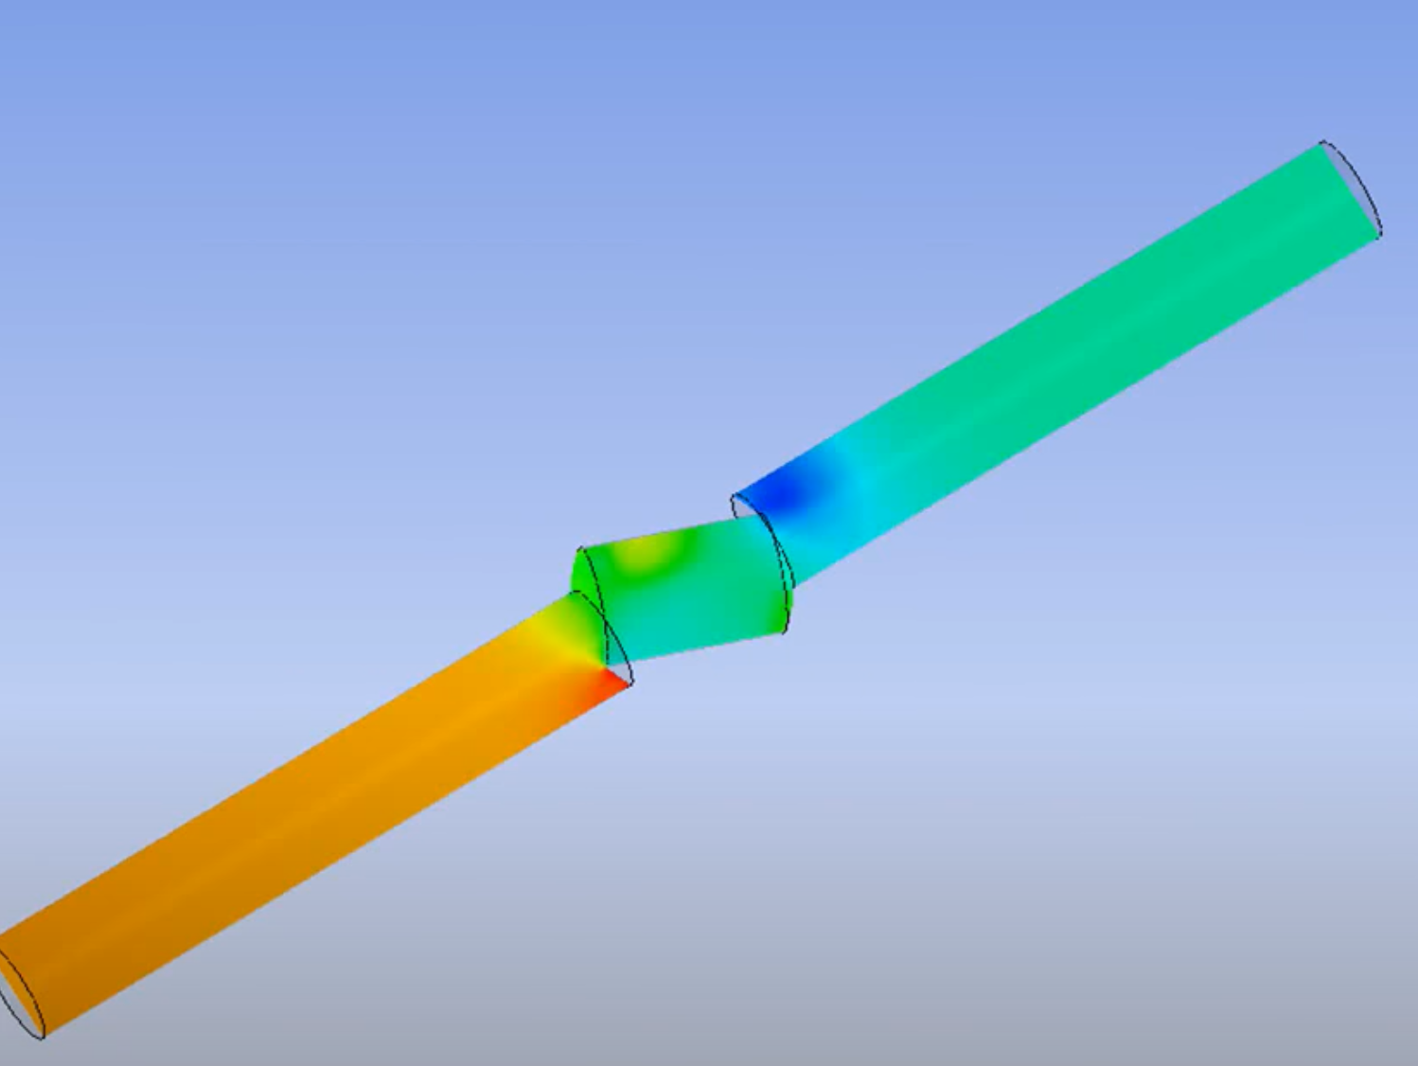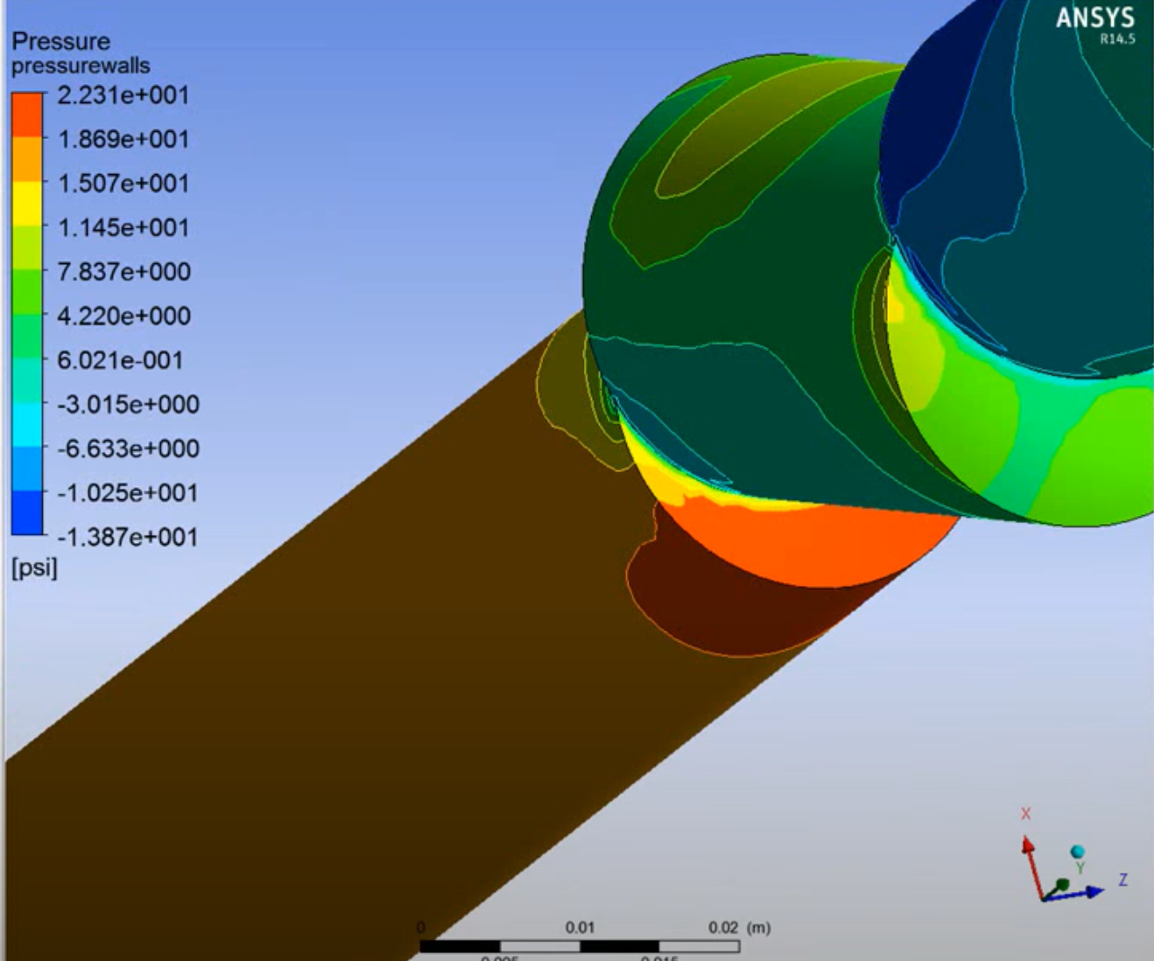

* The first pressure contour shows high pressure at the end of the first segment, so a second contour was created of the wall pressure at that point. Reading the values from the contour shows that the maximum pressure value at the wall is around 20 psi, which was within the margin of safety. In this case interpreting the results validated the design’s effectiveness.

Another important aspect of interpreting CFD simulation results is accounting for error and determining the accuracy of results.

*Accuracy of Results*

* Error:

Types of error in CFD simulations include physical modeling error and discretization error. Examples of limits and possible uncertainty and errors with physical models include spatial dimensions. (2D, axisymmetric, 3D), temporal dimensions (steady-state, unsteady), equations. (Navier-Stokes, approximations), and flow boundary conditions (inflow, outflow)

* Verification and Validation:

Simulations should demonstrate iterative convergence. As the simulation iterates, the results should approach a fixed value.

External Links:

Introduction on using CFD-post with ANSYS <https://www.afs.enea.it/project/neptunius/docs/fluent/html/cfd/node2.htm>

Post-processing

<http://www.cfdyna.com/CFDHT/PostProcess.pdf>

Error and validation in CFD simulation

<https://www.grc.nasa.gov/www/wind/TFAWS2007/Conducting-Reporting.pdf>

Interpreting Results

<https://www.digitalengineering247.com/article/cfd-for-design-engineers-dissecting-the-results/>

## Software Justification and Required/Recommended Hardware Specifications

* Software of choice: ANSYS (specifically ANSYS Fluent for CFD simulations)
* Features:
  + Fully integrated into the ANSYS Workbench environment, which incorporates both the modeling and fluid simulation computation
    - The Workbench allows either importing 3D models from CAD softwares such as SolidWorks and adding features such as meshes prior to fluid simulation or creating a 3D model from scratch and adding necessary features prior to simulation
  + Can solve sophisticated models for multiphase flows, viscous and turbulent flows, internal and external flows, etc.
  + Allows examination of interactions caused by multiple physics, such as fluid-structure interaction (FSI)
  + Includes shape optimization tools that can adjust geometric parameters in model until optimization goal is met
    - Uses the adjoint solver to modify the mesh from within to test effects of recommended changes
* Software specifications for installation and usage:
  + Supported platform and operating system: Microsoft Windows 10, 64-bit
  + Minimum hardware requirements:
    - Processor(s): Workstation class
    - 4 GB RAM
    - 25 GB hard drive space (connected hard drive applicable)
    - Computer must have a physical C:/” drive present
    - Graphics card and driver: Professional workstation class 3-D
    - OpenGL-capable
  + Recommended hardware specifications:
    - A processor with at least 4 cores
    - 4 GB (or higher) graphics card
      * NVIDIA cards have shown good results
    - 16-128 GB of RAM based on problem size
    - Two 1 TB PCIe hard drives in a RAID 0 configuration
      * This is the fastest performance configuration and should provide plenty of space for analysis models
    - A hardware RAID controller and not a software RAID controller
      * Software RAID controllers can actually hurt performance
    - 17" or larger flat panel display
      * Dual monitors are often desirable

# CFD Protocol in ANSYS

## ANSYS Fluent

### Student Installation Link

<https://www.ansys.com/academic/free-student-products>

* NOTE: the student version is limited to meshing 512,000 elements, so if you require fine mesh and/or will be using a large and complex model, it is recommended to use the Georgia Tech Virtual Lab (can be much slower than the student version installed locally on your PC)

### Instructions for Using ANSYS on Georgia Tech Virtual Lab

* Go to<https://mycloud.gatech.edu/vpn/index.html>, enter your Georgia Tech login information, and install Citrix Receiver when prompted
* After opening Citrix Receiver, you will reach a page with the tabs Home, Apps, and Desktop → click on Desktops → BME-2021 → Open
* Once loaded into the remote desktop, enter “About your PC” into Windows search bar and look for the remote desktop number being used within Device Name (should have the syntax BME-2021-#)
  + Every time you log into a remote desktop to use ANSYS, you will need to record the date and time you logged in, remote desktop number used, and time you log off when you do (recommended to create a Word document to maintain this log)
* Search “Workbench” in Windows search bar to open ANSYS Workbench
* In order to open files from your PC, will need to copy the files onto a flash drive and locate the flash drive within Windows Explorer of remote desktop
  + If a window appears asking for permission to access local files, select read and write
  + NOTE: as of now, BME-2021 VLab still uses ANSYS 2020 and SolidWorks 2020, so you cannot open ANSYS 2021 and SolidWorks 2021 files within VLab (you can install full version of SolidWorks 2021 locally on your PC through Georgia Tech)

### Creating Meshable Domain for External Fluid Flow

* Open design in SolidWorks
* After deciding upon flow direction, right-click on plane that fluid will flow into from Feature Tree → click Create Sketch
* Draw a circle or rectangle that encompasses the entire part face → click Boss Extrude in Feature Tree → under Blind, select “Through all” → click on the arrow to the left if extrusion is facing wrong way → uncheck “Merge result” → click Extrude
* **Make the main design part and outside solid separate entities**:
  + Select “Intersect” within Features → make sure both the Cut-Extrude options are selected within the feature tree → click Intersect → uncheck “Merge result” at bottom → click the green check mark at top
* **Save the model as a STEP (.stp) file** and open ANSYS Workbench application
* Double-click on Fluid Flow (Fluent) within Toolbox
  + Within Cell A, right-click Geometry → click Import Geometry → click Browse… → find the .stp file
  + Once the file is selected and there is a check mark next to Geometry in Cell A, right-click Geometry → click Edit Geometry in DesignModeler
  + Once in DesignModeler, click Generate towards top left of screen and wait till the two parts show up within Tree Outline
  + Right click the main geometry from the Tree Outline → select Suppress Body
  + Close the page and return to Workbench
* Within Cell A, right-click on Mesh → click Edit
  + **Optional but recommended**: can **name each face** depending on their function (“velocity inlet” for face where fluid will enter through, “pressure outlet” for face where fluid will exit through, “symmetry” for cut face if design was symmetrical, “far field” for the remaining face(s)) by selecting each face and clicking Create Named Selection
  + Click Mesh within Tree Outline and click Update to add meshing
  + Close the page

### Creating Meshable Domain for Internal Fluid Flow

* **Save the model as a STEP (.stp) file** and open ANSYS Workbench application
* **Repeat all steps from external fluid flow** up to generating the parts in the DesignModeler
  + To create the **inlet and outlet caps** for your model, click on Concepts at the top → Surfaces from Edges → ctrl+select the outermost edges of your desired internal fluid domain (each circular edge is usually separated into two so make sure you have the entire edge selected for all inlet and outlet faces) → click Apply on the bottom left hand side → click Generate near the top
  + Click on Tools → Fill → next to Extraction Type, change By Cavity to By Caps (if you want to fill through specific bodies inside entire fluid domain only, select them under Target Bodies; else leave as All Bodies → click Generate near top again
  + Expand the Parts under Tree Outline → there should be a part named “Solid” corresponding to the filled fluid domain → right-click and rename it to “Fluid” if preferable and right click on all other parts you don’t want included in fluid domain → click Suppress Solid Bodies → ensure that only desired fluid domain is seen
  + Close page and return to Workbench
* Click on Mesh within Cell A and **repeat steps from external fluid flow**

### Setting Up Fluent and Running Simulation

* Within Cell A in Workbench, double click Setup → leave options unchanged and click START
* Click on the + next to Models on the left and select type of model being simulated (most popular: **Viscous - Laminar**) → click Edit → select most appropriate model subclassification (Inviscid is to model fluid with 0 viscosity, incompressible for constant density, Laminar for fully developed velocity profile, k-epsilon and k-omega involve turbulence, etc.)
  + **If wanting to model turbulence, can select k-epsilon** and click OK at bottom of screen
* Click on the + next to Materials on the left and + next to both Fluid and Solid to confirm/change the **defined fluid and solid materials**
  + For fluid, double-click air if intending to replace it → enter name of fluid at top → specify if density and viscosity are constant or not → enter the density and viscosity of fluid (and any other parameters if needed such as specific heat, thermal conductivity, etc.) → click Change/Create → select No for Change/Create mixture and Overwrite air → click Close → ensure named fluid appears next to air under Fluid
    - **Blood properties**:
      * Density = 1060 kg/m3
      * Viscosity = 0.003 kg/m-s
      * Cp (Specific Heat) = 3513 j/kg-k
      * Thermal Conductivity = 0.44 w/m-k
    - Fluent also has properties for common fluids, such as air and water, built-in
      * Can search for fluid under Fluent Database
  + For solid, double-click on aluminum and repeat the same procedure with entering relevant parameters as necessary (mostly only density is needed)
    - Can also search for specific solid materials under either Fluent Database (change material type to solid) or GRANTA MDS Database
* To **ensure correct fluid is selected** for simulation, click on + next to Cell Zone Conditions → + next to Fluid → double-click on selection underneath → next to Material Name, ensure correct liquid is specified → click Apply then Close
* To apply all necessary **boundary conditions**, click on Boundary Conditions on the left and ensure the type of each labeled face under Zone matches intended function
  + If faces were named “velocity inlet”, “pressure outlet”, etc., the Type should have been automatically assigned (“far field” will be labeled as “wall”)
  + Click on velocity inlet face → click Edit → enter intended **Velocity Magnitude (and Initial Gauge Pressure if applicable)** 
    - Under Turbulence, can select Intensity and Length Scale if **turbulent length scale is known**
  + Click on pressure outlet face → click Edit → enter intended Gauge Pressure and select Intensity and Length Scale if turbulent length length scale is known
  + Click on far field face → click Edit → ensure that **Stationary Wall** under Wall Motion and No Slip under Shear Condition are selected if intended
* Under Solution section on left, double-click Initialization → select Standard Initialization under Initial Methods → select velocity inlet under Compute from if intending iterative solver to **initialize from velocity inlet face** → click Initialize
* Double-click on Run Calculation on the left → enter **Number of Iterations (100 if unsure)** → click Calculate
* Ensure that the plot is showing trend towards convergence of all residuals until completing all iterations
* Can close Fluent since everything should be saved automatically, but will need to save the project file in Workbench (File → Save As if not yet saved)

### Post-Processing Results

* Double-click on Solution within ANSYS Workbench and click on the Results tab at the top of screen
* To create a **contour**, within the Graphics section on the top, click **Contour** → name contour if needed → under Contours of, specify either **Pressure, Velocity, etc.** → specify specific type of contour in the next section (most common ones are **Total Pressure** and **Velocity Magnitude**) → ctrl+click all surfaces you want to include within contour → click Save/Display to display contour
  + In order to obtain contour of **cross-section of model**:
    - Within Surface section on the top, click Create → Plane → name it for identification → specify orientation of plane (either XY, YZ, ZX, a point and normal vector, or three points) → specify length along the coordinate that remains constant in the plane (applies for XY, YZ, or ZX planes) → click Create
    - Click on Contour and repeat all steps above except for selecting the plane for the surface
* To create a **numerical plot**, click Create under Surface section → Line/Rake → name line for identification → check “Line” and click Reset → Specify Type: Line → for the End Points, specify first and last x, y and z coordinates (if wanting to create line only along x, y or z axes, specify first point at -10 and last point at 10 for that axis to encompass the entire model, and leave the other axes the same) → Create
  + Next, click on XY Plot under Plots section → New → name plot for identification → specify plot direction (depends on direction of line) → specify function to plot (**Pressure, velocity, etc.**) and the section below that → keep X Axis Function as “Direction of Vector” → choose the line under Surfaces → click Save/Plot to obtain a parameter as a function of distance for the model
* Additional post-processing tools: **Vectors, Pathlines, Particle Tracks, etc.**

### 

### External References for Protocol

* Parts 1 and 2 Video Tutorial: <https://www.youtube.com/watch?v=NYwnLIdBBqw>
  + Additional reference for Part 2: <https://www.youtube.com/watch?v=_AII6cpzos8> (from the 7-minute mark onwards)
* Part 3 Video Tutorial: <https://www.youtube.com/watch?v=rueRyqPHjNc>
* Part 4 Video Tutorial: <https://www.youtube.com/watch?v=JqpSGGNm9ss> and <https://www.youtube.com/watch?v=B4hZdMDmSOA>
* Step-By-Step Instructions with Images for All Steps Involving ANSYS Workbench (After Modifying Model in SolidWorks): <https://drive.google.com/drive/u/0/folders/0By-hZbg-3WSveVZ0NlZKZjFzTEU>

# Model Inputs

## Modeled Assemblies

## Assumptions/Boundary Conditions

Assumptions

* Structural elements will remain axisymmetric with the catheter
* The pressure differential will be great enough to prevent any lateral movement, so only translational motion will be present
* Standard blood pressure of 120/60 mmHg*
* Structural elements can be modeled as an infinite train of touching spheres
* Pressure should be higher at the proximal end
* No external forces except the force to advance and small resistance from the valve cap
* Inertial effects can be ignored
* Structural elements and fluid should have the same mean velocity
* No angular velocity
* Laminar flow, no turbulence
* Take into account pressure in the LA which is different than BP

Source: Assumptions for CFD Project (Current folder)

Properties and Parameters

* Blood properties:
  + Density = 1060 kg/m3
  + Cp (Specific Heat) = 3513 J/kg-k
  + Thermal Conductivity = 0.44 w/m-k
  + Viscosity = 0.003 kg/m-s
* Temperature: 37 degrees celsius
* Limits for catheter length and size: 100 cm or 80 cm
* Structural element sizes: 1- 2.381mm DIA
* Tube ID = 2.79 mm

Source: Assumptions for CFD Project (Current folder)

Boundary Conditions:

Source: 3008-0003.rv1.IS177 Delivery System Fluid Dynamics Simulations Instructions

Pressure:

* Fluid pressure: < 100 psi

Back Pressure:

* The result of all possible pressures and resistances encountered
* P*: 2-50 mmHg or 0.04-1 psi or 1.27’’ of water

Source: 3008-0003.rv1.IS177 Delivery System Fluid Dynamics Simulations Instructions

* Native pressure in LA/LAA
  + Left Atrial Pressure: 6 - 12 mmHg
  + Left Atrial Pressure (Persistent AF): 18 +- 5 mmHg
  + Left Atrial Systolic Force (if relevant): 12.5 ± 4.7 kdynes v 12.2 ± 4.7 kdynes
  + Pericardial pressures: 0 - 4 mmHg
  + Atrial Ejection Force (if relevant): 19.0 +- 10.6 kdynes
  + Source: 3008-1501.rv1.IS177 FEA Procedures
* Resistance from cap valve and sleeve valve
  + Maximum pressure at the wall ~ 20 psi
* Pressure needed to begin chamber expansion
  + Band should hold position against 1-2 N tug force
  + Source: 3008-1005.rv1.IS177 FEA Spherical Chamber Project-6
* Resistance from foam sleeve at catheter tip

## Testing Parameters

* To run the CFD simulation, the following parameters need to be set.
* Inlet Velocity:
  + Set according to testing data obtained last year
  + Velocity of fluid entering tube = 8.17 cm/sec
  + Supersonic/Initial Gauge Pressure: 977721 Pa
    - Average force applied to syringe plunger = 6.62N
    - P = F/A = 6.62 N / (pi*(0.0014 m)^2) ~ 977721 Pa
* Outlet Gauge Pressure:
  + Set to 0 Pa
* Walls:
  + Set the wall motion to “Stationary”
  + Set the shear condition to “No Slip”

Example of entering parameters in ANSYS for inlet, outlet, and walls: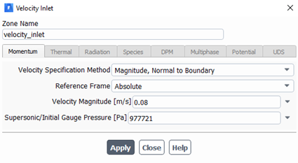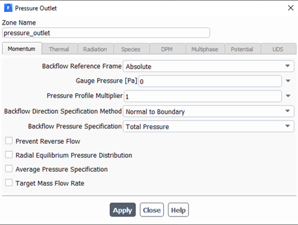

Source: Catheter Body Ansys Simulation Presentation (Internal Ref)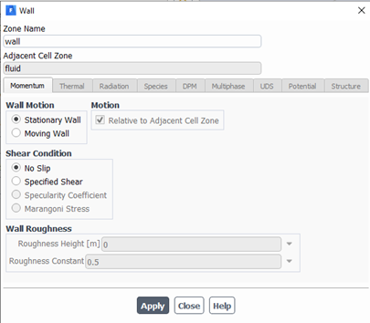

# Simulation Results and Analysis

## Internal Laminar Water Flow Through Empty Catheter Body and Tip Assembly

3D contour of total pressure from entrance to exit:

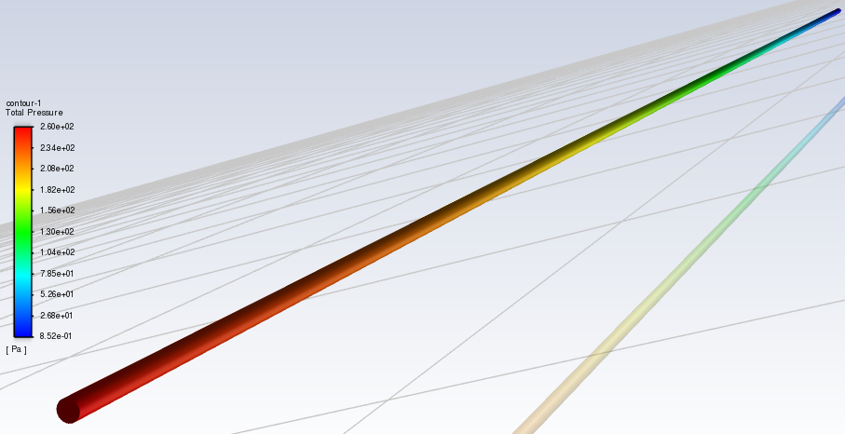

3D contour of velocity magnitude at entrance and exit:

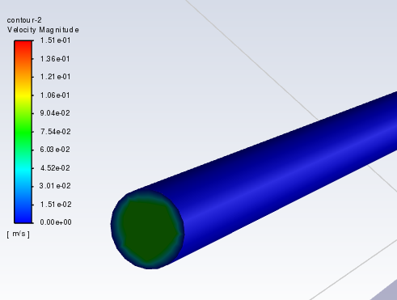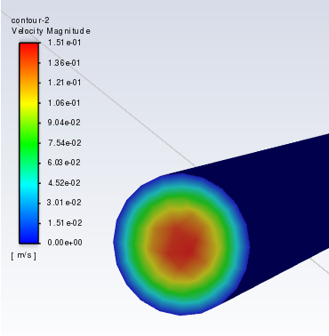

2D contour of velocity magnitude:

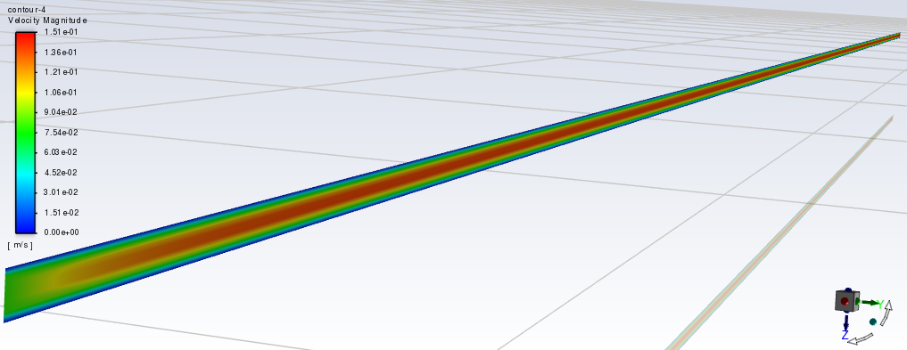

Plot of total pressure along central axis vs horizontal distance away from center of assembly:

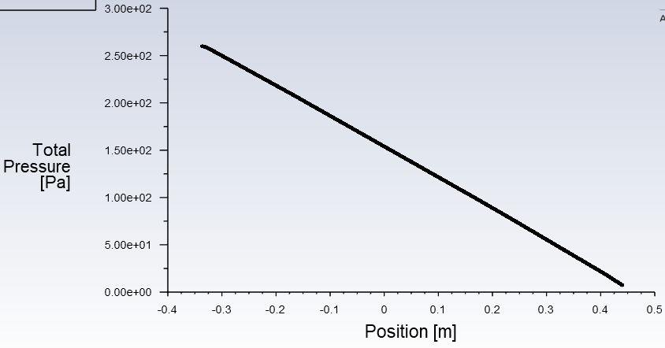

Plot of velocity magnitude along central axis vs horizontal distance away from center of assembly:

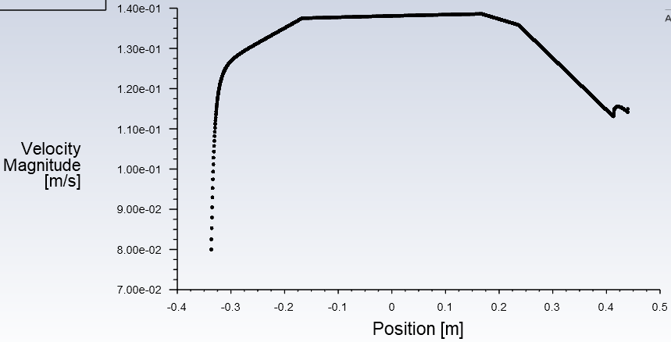

## 

## Internal Laminar Water Flow Through Catheter Body and Tip Assembly Filled with 2.381 mm Spheres Along Central Axis (Spaced ~0.05 mm apart)

Meshed fluid domain (with cross-sectional cut for visualization):

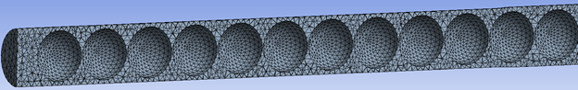

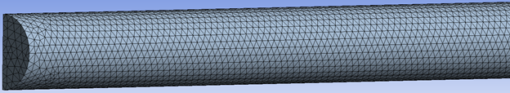

Boundary conditions:

* Inlet velocity: **0.239 m/s**
  + Inlet velocity = inlet volumetric flow rate / inlet cross-sectional area
  + Inlet volumetric flow rate = 1.44 mL/s from Gerald’s tests
  + Inlet cross-sectional area using 2.76 mm ID catheter = 6.02*10^-6 m^2
* Inlet pressure: **112953 Pa**
  + Inlet pressure = force exerted by fluid at inlet / inlet cross-sectional area
  + Force exerted by fluid at inlet = 0.68 N from Gerald’s tests
  + Same inlet cross-sectional area as above

2D cross-sectional contour of velocity magnitude at inlet end: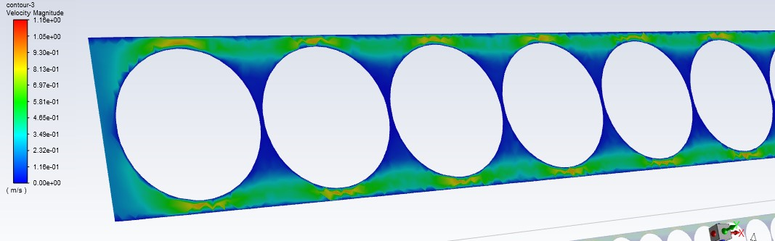

2D cross-sectional contour of velocity magnitude at outlet end:

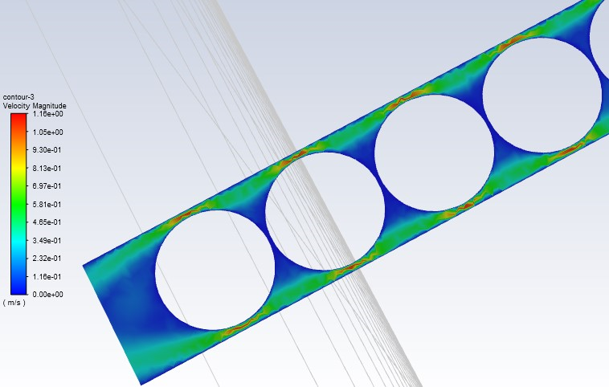

* According to CFD-Post Function Calculator, the maximum velocity across cross-section is 1.1635 m/s and average velocity is 0.4029 m/s

2D contour of velocity magnitude at outlet face: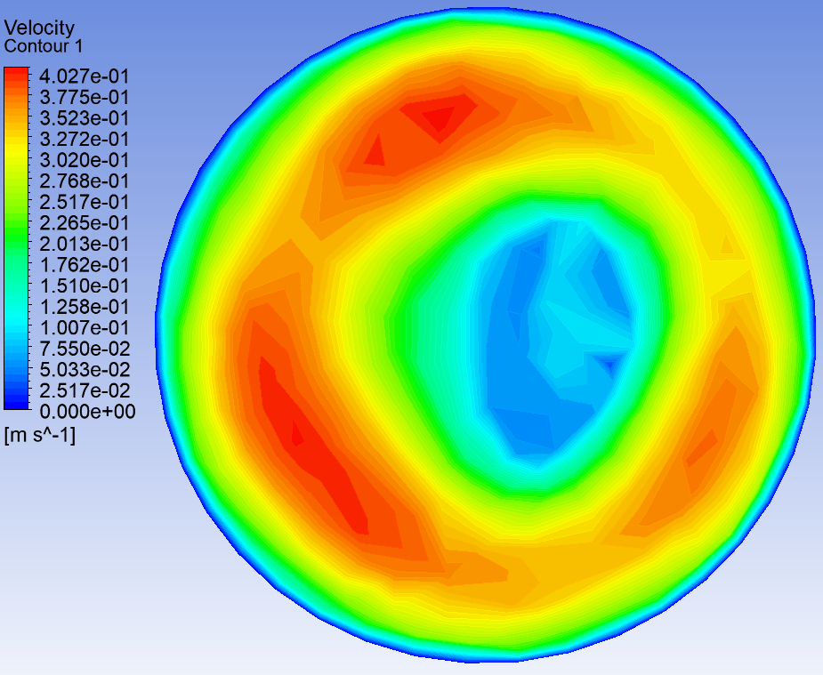

* According to CFD-Post Function Calculator, the maximum velocity at outlet is 0.4183 m/s and average velocity at outlet is 0.2543 m/s

2D contour of total pressure at outlet: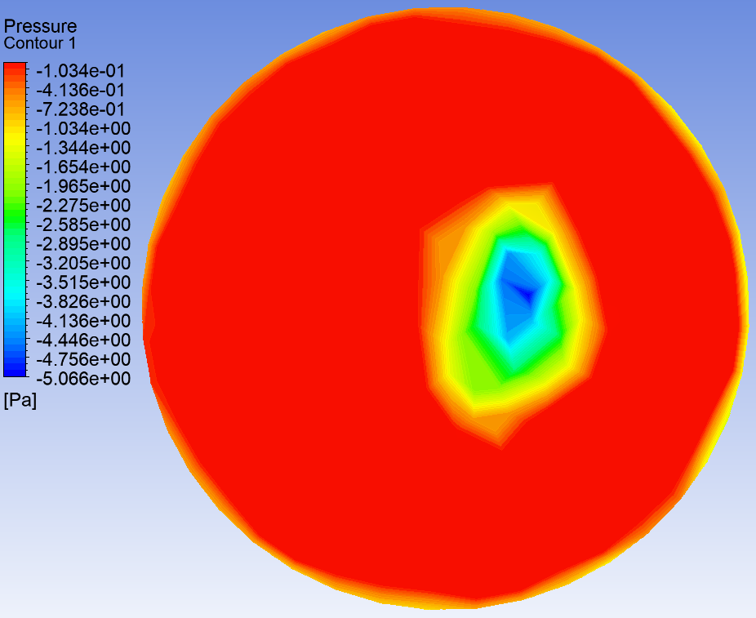

* The pressures are negative due to being back pressures
* According to CFD-Post Function Calculator, the maximum back pressure at outlet is 7.5063 Pa and average back pressure at outlet is 0.1963 Pa

# **Deliverables & Goals**

## Main goals:

* To determine the optimal clearance between the catheter and the structural elements using a simulation program
* To identify the optimal clearance that allows for the fastest delivery of the structural elements to the chamber device
* To determine the optimal dimension of the inner diameter of the catheter and the optimal dimension of the structural elements
* To determine the materials for structural elements and tube that provide the best results, which can be characterized as the fastest velocity with the same clearance

## Deliverable Overview:

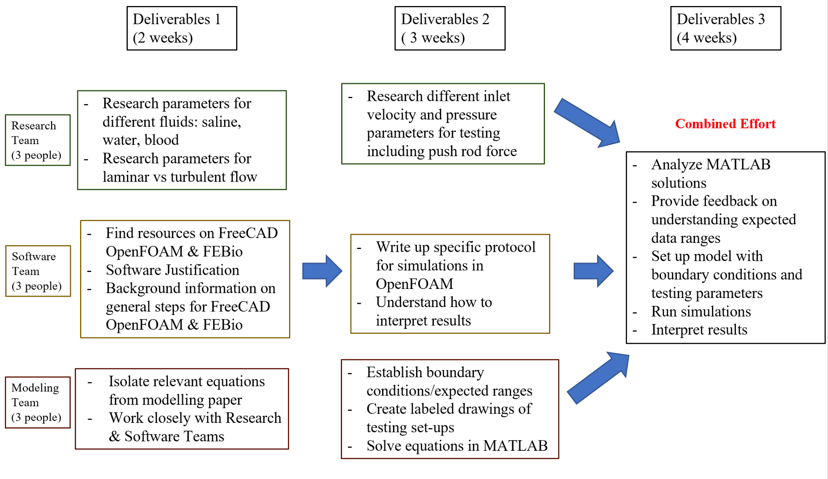

### Deliverables 1 - Team 1

**Main Goal**: Get preliminary results using equations from Bungay and Brenner (1973) in MATLAB

**Current goals**: Understand MATLAB’s CFD capabilities and find relevant equations in paper

**Steps/Questions:**

* Research the CFD capabilities of MATLAB
  + What conditions can/need to be defined?
  + How do these equations need to be organized/formatted?
  + What will the results look like?
  + How will the results be interpreted?
* Review modeling paper by Bungay and Brenner (1973) in Modeling > Delivery System CFD > Internal Ref > 8309-2001.IS177.pdf Motion of Closely-Fitting Sphere in Fluid-Filled Tube
  + Which case most closely resembles our testing conditions?
  + Which equations are associated with modeling this scenario?
  + What parameters are defined by these equations?
  + What are the assumptions/constraints described?
  + What aspects are different from our testing conditions?
  + What results will these equations yield when solved?

**Deliverables**:

* Justification for using MATLAB as a preliminary solving resource and its capabilities for providing theoretical solutions
* List of necessary equations, parameters, assumptions, and constraints and why they are appropriate to use to model our scenario
* Explanation of any differences or gaps that limit the models relevance to our ideal testing conditions
* Explanation of expected results and how they could potentially be interpreted to help validate our model or define relevant boundary conditions

**Group size**: 2; Ashka Patel

**Time frame**: 2-3 weeks

### Deliverables 1 - Team 2

**Main goal**: Create modeled assembly for testing and establish CFD protocol in ANSYS

**Current goals**: Create modeled assembly with FEA team, provide justification for ANSYS, and provide background info on CFD

**Steps/Questions:**

* Work with FEA team to finish modeling the components of the delivery system to create a full assembly
  + What aspects/components are most difficult to model?
  + What dimensions are still undefined?
  + What dimensions are being optimized during testing?
  + Which component interactions may cause additional pressure or need to be tested under different conditions?
  + Which parts should be tested first? (Simplest model first)
* Begin to learn ANSYS (Fluent specifically) and understand its CFD capabilities
  + What capabilities will we use to test our components?
  + Why is this program appropriate for our modeling needs?
* Research general steps and background information on CFD
  + What is CFD?
  + What testing conditions are included in CFD?
  + What kind of model is needed for rigid body testing?
  + What are boundary conditions and how are they defined?
  + How are various loads defined?
  + What is a mesh and how is a high quality mesh created?
  + What will the results look like and how will they help us?
  + How will results be interpreted?

**Deliverables:**

* Provide 3D assembled models for testing
* Written justification for why ANSYS is an appropriate choice for our purposes
* Detailed background info and visual examples (when applicable) to describe the concepts/questions listed above
* Written procedures for general protocol for running a CFD simulation

**Group size**: 2; Katelynne Berland and Aniket Venkatesh

**Time frame**: 2-3 weeks

### Deliverables 1 - Team 3

**Main goal**: Define necessary parameters/assumptions for initial simulation

**Current goals**: Define testing set-ups (tube lengths/diameters and structural element sizes to be tested) and calculate estimated back pressure value

**Steps/Questions:**

* Define tubing and structural element dimensions that will be tested
  + Which lengths and diameters of tubes are potential options for the final prototype?
    - Sphere size (diameter) options vary between 1 mm to 2.381 mm
    - Tube length is constant at 1 m
    - Inner and outer diameters of the tube vary depending on the sphere size within the range mentioned above.
      * Inner diameters range from 1.4 mm to 2.79383 mm
      * Outer diameters range from 2.3 mm to 3.65743 mm
  + What are common sizes for similar procedures?
    - Tube outer diameters vary between 0.7 to 3 mm
    - Tube lengths vary between 0.65 to 1.20 m
  + Between 1mm-2.381mm diameter structural elements, which exact sizes are potential options for the final prototype and what size tubing will be paired with each size?
    - 1.0 mm
      * Sphere
        + diameter = 1.0 mm
        + +/- tolerance = 0.0254 mm
      * Catheter tube
        + length = 1 m
        + inner diameter = 1.4 mm
        + inner diameter tolerance = 0.38735 mm
        + outer diameter = 2.3 mm
        + outer diameter tolerance = ?
    - 1.5875 mm
      * Sphere
        + diameter = 1.5875 mm
        + +/- tolerance = 0.0254 mm
      * Catheter tube
        + length = 1 m
        + inner diameter = 2.0003 mm
        + inner diameter tolerance = 0.38735 mm
        + outer diameter = 2.8639 mm
        + outer diameter tolerance = ?
    - 2.0 mm
      * Sphere
        + diameter = 2.0 mm
        + +/- tolerance = 0.0508 mm
      * Catheter tube
        + length = 1 m
        + inner diameter = 2.4 mm
        + inner diameter tolerance = 0.38735 mm
        + outer diameter = 3.3 mm
        + outer diameter tolerance = ?
    - 2.381 mm
* Sphere
  + diameter = 2.381 mm
  + +/- tolerance = 0.02548 mm
* Catheter tube
  + length = 1 m
  + inner diameter = 2.79383 mm
  + inner diameter tolerance = 0.38735 mm
  + outer diameter = 3.65743 mm
  + outer diameter tolerance = ?
* Calculate back pressure value
  + What are all the possible pressures and resistances that could be encountered and what estimated values are associated with each? (some have been defined in the FEA procedures and papers provided have some relevant values)
    - Native pressure in LA/LAA
      * Left Atrial Pressure: 6 - 12 mmHg
      * Left Atrial Pressure (Persistent AF): 18 +- 5 mmHg
      * Left Atrial Systolic Force (if relevant): 12.5 ± 4.7 kdynes v 12.2 ± 4.7 kdynes
      * Pericardial pressures: 0 - 4 mmHg
      * Atrial Ejection Force (if relevant): 19.0 +- 10.6 kdynes
      * Source: 3008-1501.rv1.IS177 FEA Procedures
    - Resistance from cap valve and sleeve valve
      * Measured flow rate: 1.44 ml/sec = 5.184 L/h
      * Flow data for 2.7 mm duckbill flanged valve

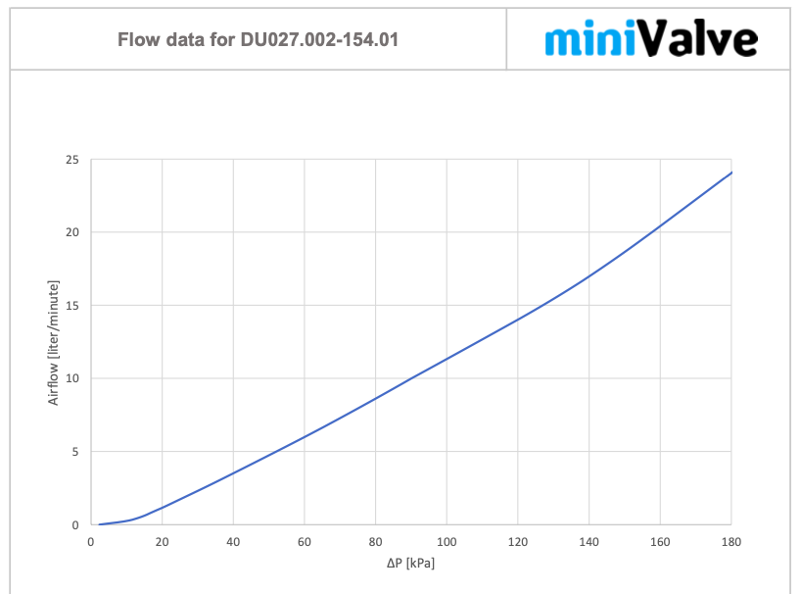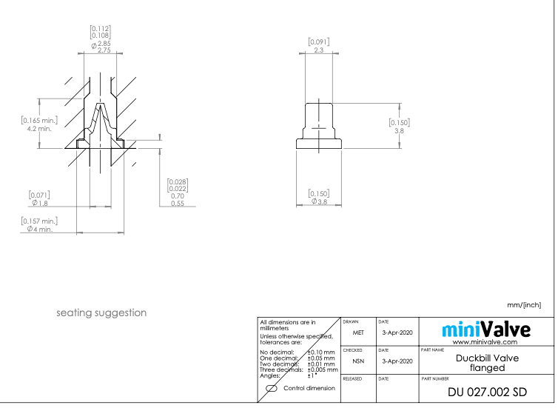

* + According to the graph, 5.184 L/h corresponds to around 52 kPa pressure = 7.542 psi
    - Patient blood pressure
      * Standard blood pressure of 120/80 mmHg
      * Fluid pressure: < 100 psi
      * Laminar flow, no turbulence
    - P* : Assumed left atrial pressure = 2-50 mmHg (max) or 0.04-1 psi or 1.27’’ of water
      * Source: 3008-0003.rv1.IS177 Delivery System Fluid Dynamics Simulations Instructions



* + - Pressure needed to begin chamber expansion

Information from the ANSYS Simulation

* + - * Velocity of fluid entering tube = 8.17 cm/sec
      * Supersonic/Initial Gauge Pressure: 977721 Pa
        + Average force applied to syringe plunger = 6.62N
        + P = F/A = 6.62 N / (pi*(0.0014 m)^2) ~ 977721 Pa
      * Outlet Gauge Pressure: 0 Pa
      * Source: Catheter Body Ansys Simulation Presentation

Information from the Experimental Testing

* + - * Volume of fluid pushed by the syringe and used to fill device chamber = 10 ml
      * Measured flow rate = 1.44 ml/sec
      * Force required to push the syringe at 1.44 ml/sec = 22.55 Newtons
        + The actual force needed to push the water (with a 3’’ head) is less than 22.55 N
      * Fluid Force: (80-22.6)N x 0.011898 = 0.68 Newtons
      * Filling requires pressures on the order of 0.68 Newtons at 1.44 ml/sec with a 39.75’’ long tube and back pressure from a 3’’ head of water
      * Expansion ratio = expanded chamber diameter/original chamber diameter = 20.55mm / 13.21mm = 1.56:1
      * Source: 3407-5006.rv2.IS191 Air and Water Testing-3

Total expected back pressure value inputs:

* + - * Left Atrial Pressure (Persistent AF): 18 ± 5 mmHg = 0.348 ± 0.0967 psi
      * Fluid pressure: < 100 psi
      * P* : Assumed left atrial pressure = 2-50 mmHg (max) or 0.04-1 psi
        + Use 0.07 (average of 0.04-1 psi)
      * Fluid Force: 0.68 Newtons (convert to pressure → P=F/A)
      * Pressure from cap valve: 7.542 psi

Sum: (0.348 ± 0.0967) + 100 + (0.07) + fluid force + (7.542) psi = 107.96 ± 0.0967 psi + fluid force

**Deliverables:**

* List of testing/model dimensions for tube and structural elements
* List of values for each pressure defined and provide total expected back pressure value

**Group size**: 2; Elif

**Time frame**: ~2 weeks

# Resources and References

## External References

### Experts/Professors

* Alexander Alexeev
  + Professor, Anderer Faculty Fellow

George W. Woodruff School of Mechanical Engineering, Love Bld. 214

Phone: 404-385-3659; Email: alexander.alexeev@me.gatech.edu

Web: www.me.gatech.edu/faculty/alexeev; cfms.gatech.edu

Recommendation: OpenFoam

● Marilyn J Smith

* Professor and Director of Vertical Lift Research Center of Excellence

Daniel Guggenheim of Aerospace Engineering

Recommendation: For people in the US, the best recommendation is FUN3D from NASA; for commercial codes, Star CCM is good.

● Mitchell L.R Walker II

* Professor and Associate Chair for Graduate Programs

Daniel Guggenheim of Aerospace Engineering

Recommendation: COMSOL or Fluent

● Cyrus K. Aidun, PhD

* Professor

G.W. Woodruff School of Mechanical Engineering

Parker H. Petit Institute for Bioengineering and Bioscience

Recommendation: Has an inhouse research code developed in his group for blood flow simulations. This code can also analyze particles in blood flow. Him and his team can help with simulations through projects at GT. See pdf associated with this document written by professor Aidun.

● Vigor Yang

* Ralph N. Read Chair and Regents Professor

Daniel Guggenheim School of Aerospace Engineering

Recommendation: COMSOL or Fluent

● Timothy Lieuwen

* Professor of Aerospace Engineering (Adjunct Professor in the Woodruff School)

Heat Transfer, Combustion and Energy Systems Recommendation: Fluent

● Suresh Menon

* Hightower Professor

Professor of Aerospace Engineering

Recommendation: Fluent or OpenFoam

● Stephen M. Ruffin, Ph.D.

* Professor and Associate Chair, Aerospace Engineering

Director, NASA Georgia Space Grant Consortium

Voice: 404-894-8200; Email: stephen.ruffin@ae.gatech.edu

Website: http://www.ae.gatech.edu/people/stephen-m-ruffin

Recommendation: Ansys Fluent or STAR-CCM+

● Adam M. Steinberg | Associate Professor

* Guggenheim School of Aerospace Engineering

Phone: 404-894-1130 | Email: adam.steinberg@gatech.edu Web: http://steinberg.ae.gatech.edu

Recommendation: OpenFoam

### Helpful Websites

* Info about CFD basics in ANSYS Fluent: <https://www.slideshare.net/muhammadshujan/cfd-ansys-fluent>
* Info about CFD procedures from NASA: <https://www.grc.nasa.gov/www/wind/valid/tutorial/process.html>

## Internal References

Modeling > Delivery System Simulation > Internal Ref

* Project Goals: 3008-0003.rv1.IS177 Delivery System Fluid Dynamics Simulations Instructions
* Journal Article: 8309-2001.IS177.pdf Motion of Closely-Fitting Sphere in Fluid-Filled Tube

Modeling Folder

3102-0001.rv2.IS177.pdf New Information-6

Modeling>FEA>Internal Ref:

3008-1007.IS177 FMT Common Reference geometry

# Next Steps for the Project

## ANSYS Simulations

* Perform additional fluid flow simulations through catheter body + tip assembly filled with spheres while varying the following parameters:
  + Note: Have more than one person working on running simulations to expedite the process and minimize issues with virtual lab
  + Make the spheres movable such that they will all move with a uniform velocity down the catheter and ensure the simulation runs until all spheres have exited the assembly (test multiple different velocities too)
  + Velocity of flow at inlet
  + Pressure at inlet
  + Fluid flow model (so far, the laminar, inviscid flow model has been used but would like to test various turbulence and viscous flow models)
  + Fluid classification (so far, liquid water has been used but would like to test different fluids such as saline, blood, etc. using custom-defined parameters)
* Learn more about and analyze the qualitative and quantitative results of each simulation
  + Currently, the main goal has been to perform simulations and obtain the following results: qualitative results include pressure and velocity contours at inlet, outlet, and cross-section of assembly and quantitative results include the maximum and average velocity and pressure at the inlet, outlet, and cross-section of assembly
  + Would like to learn and understand how to use those results to optimize the clearance between the spheres and inner catheter wall, the velocity of spheres and accompanying fluid, and the force exerted by the spheres and fluid flow on the inlet face

## FreeCAD Simulations

* Perform simulations through FreeCAD